**Practical No. 1**

**Installation and preparing the lab ready Virtual or physical machine with Kali Linux.**

Step 1: Download & install Virtual Box

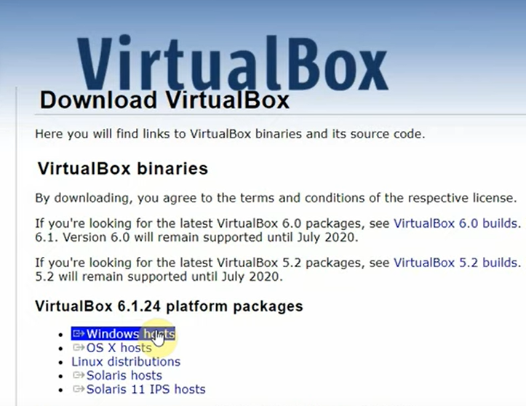

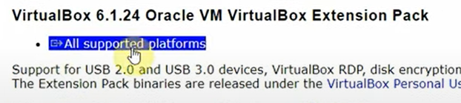

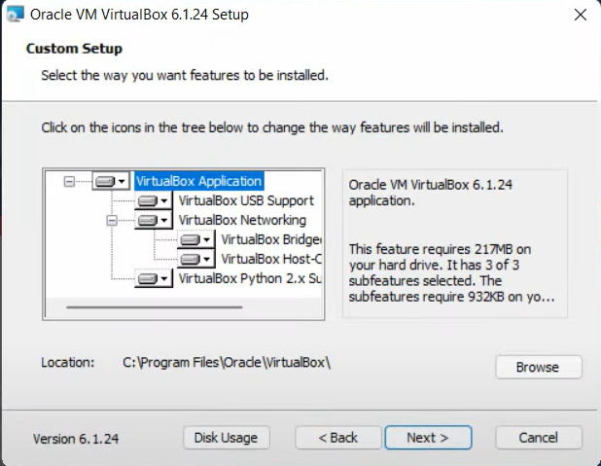

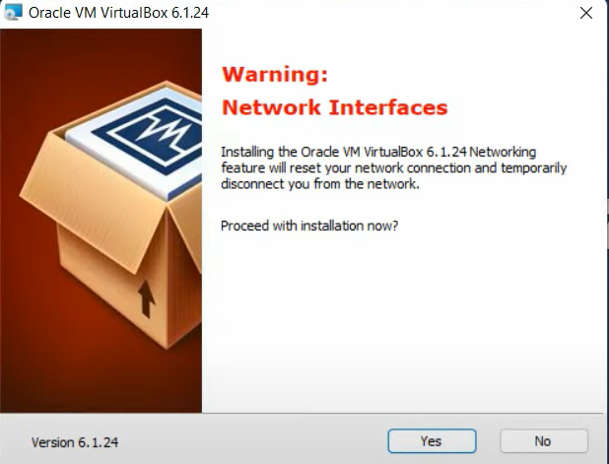

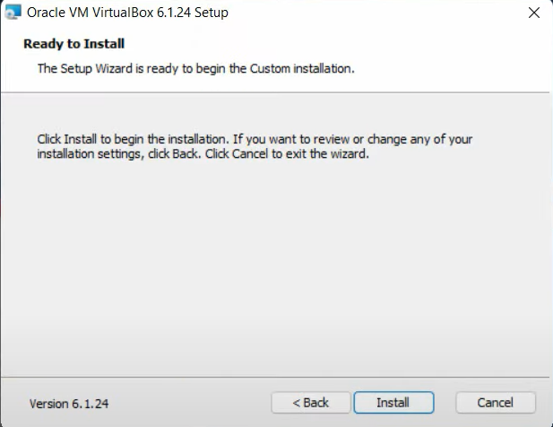

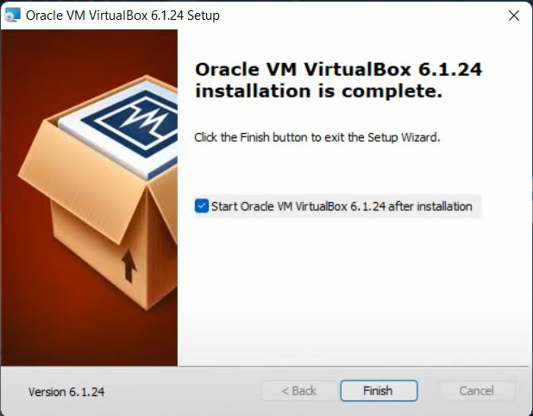

Step 2: Add a Virtual Box Extension

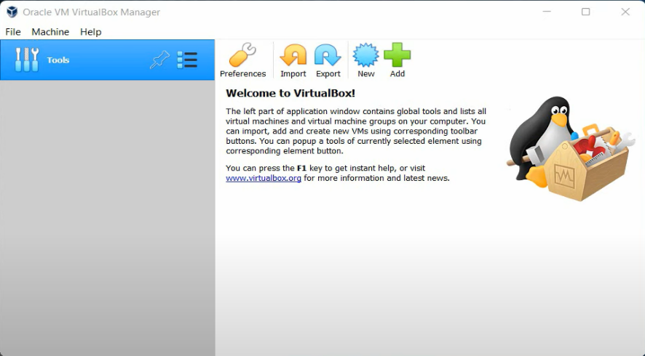

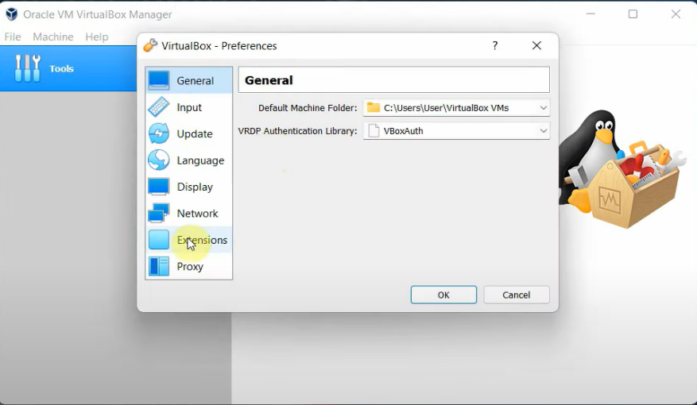

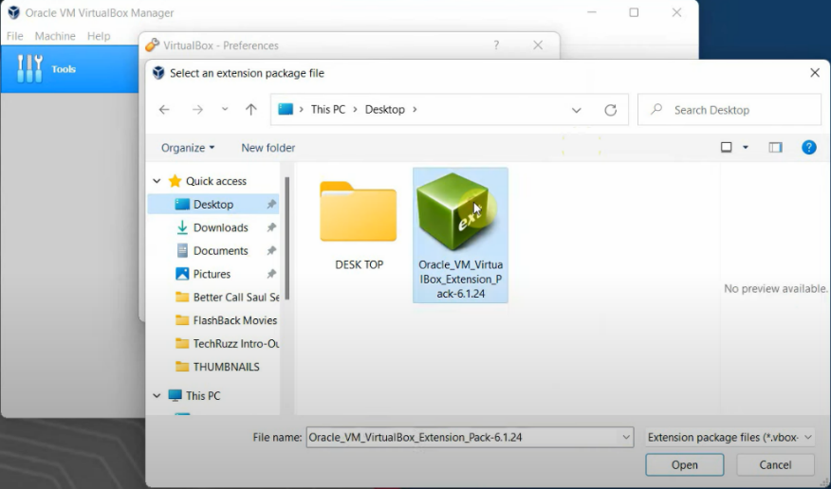

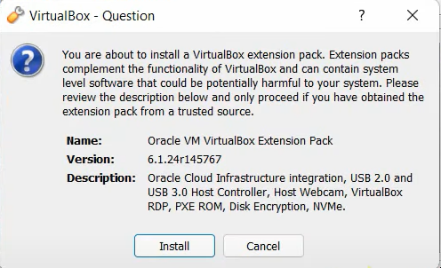

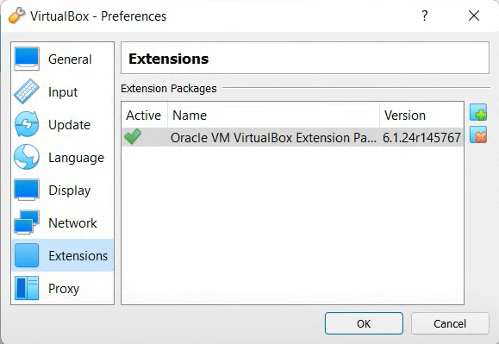

Step 3: Download and install Kali Linux

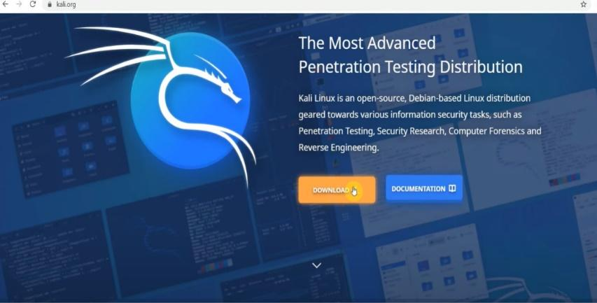

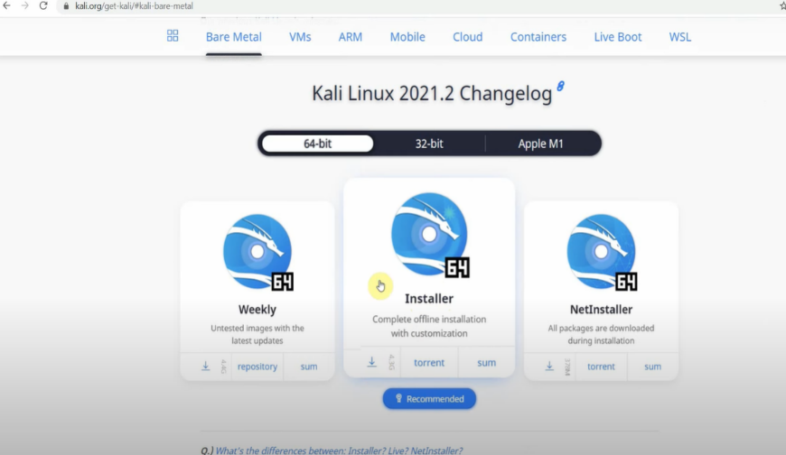

Step 4: Add Kali OS to Virtual Box.

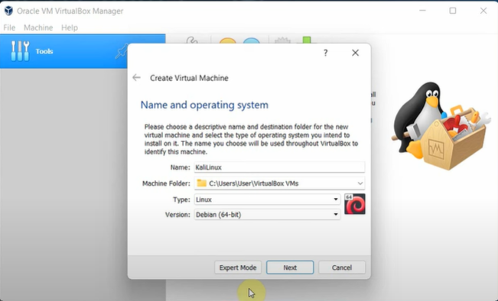

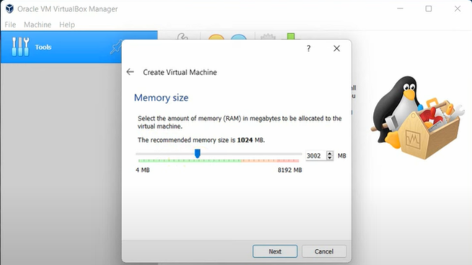

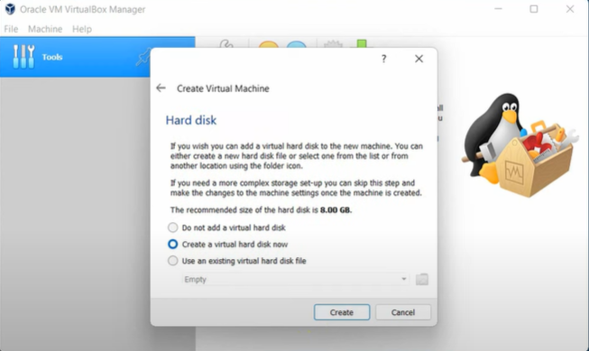

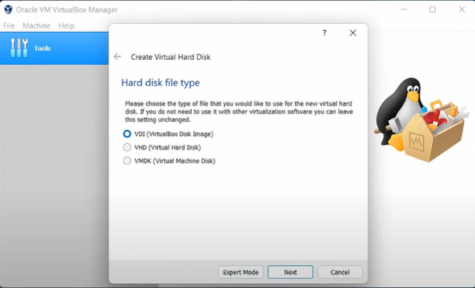

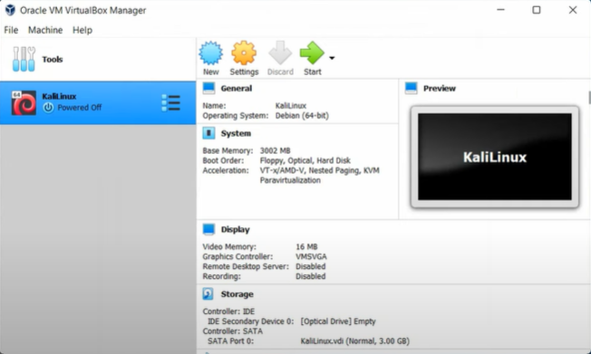

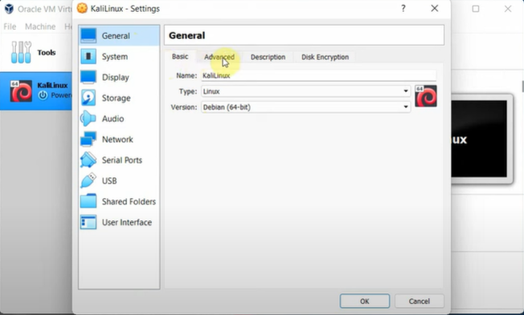

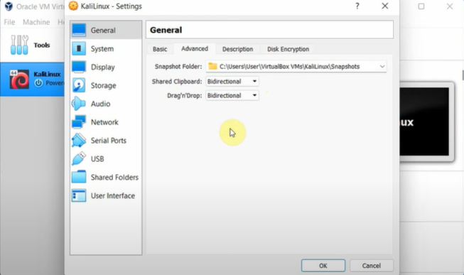

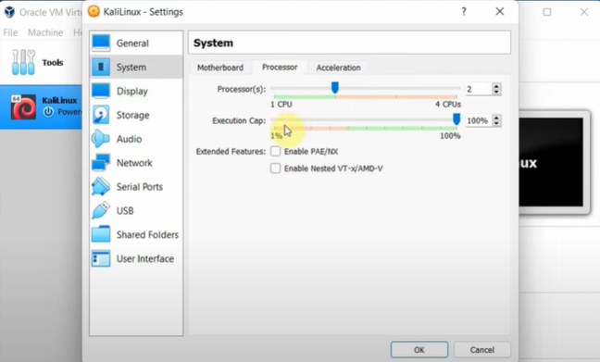

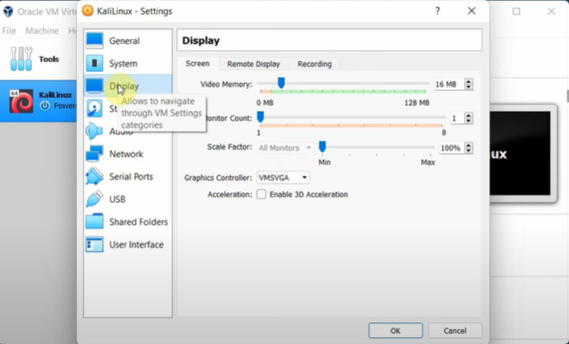

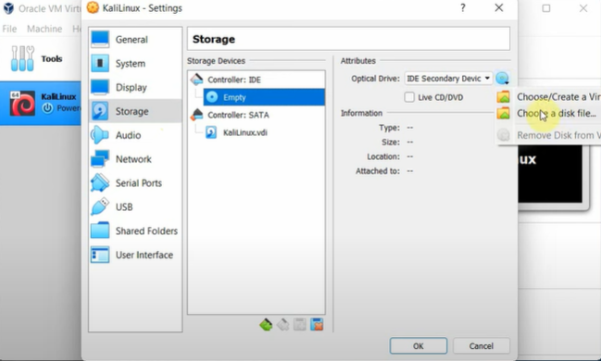

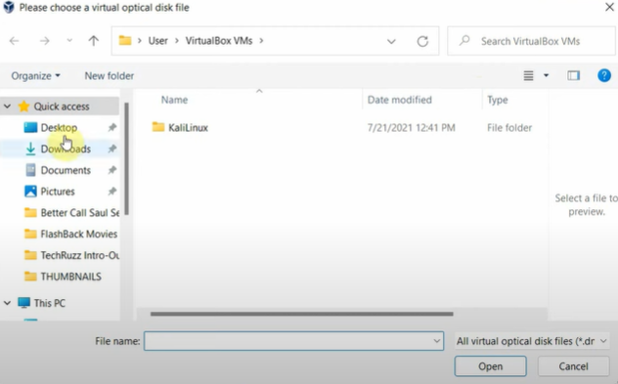

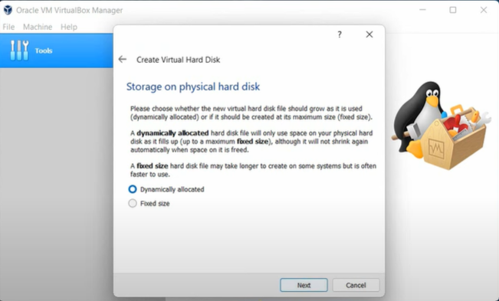

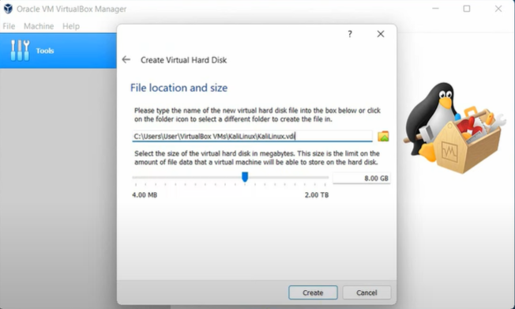

Step 5: Start Kali Linux Virtual Machine.

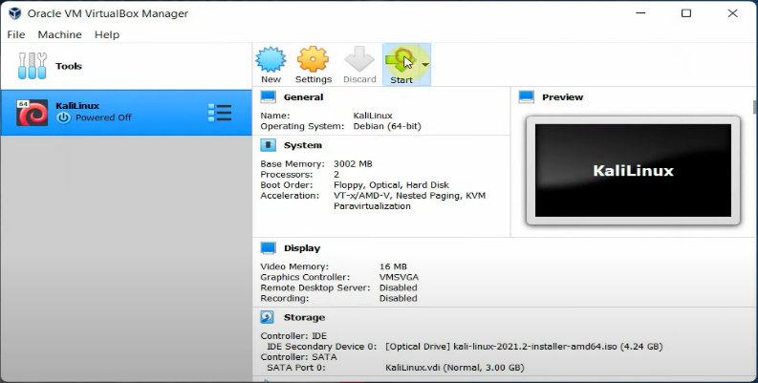

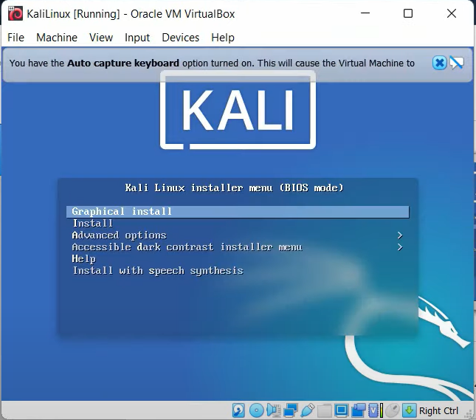

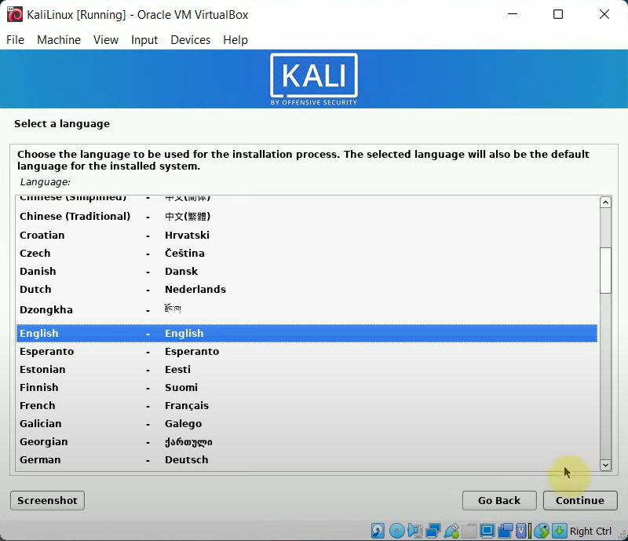

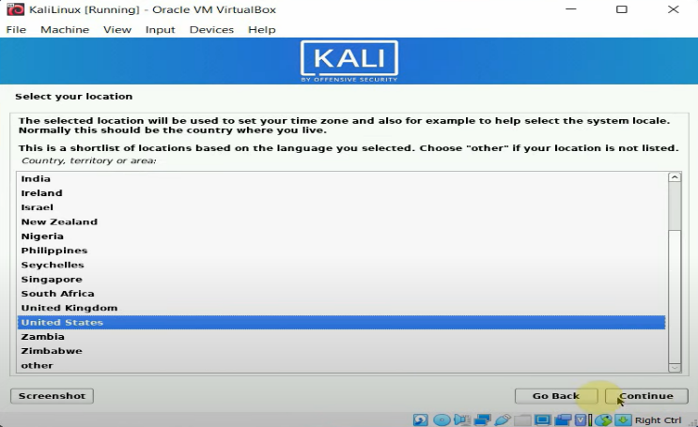

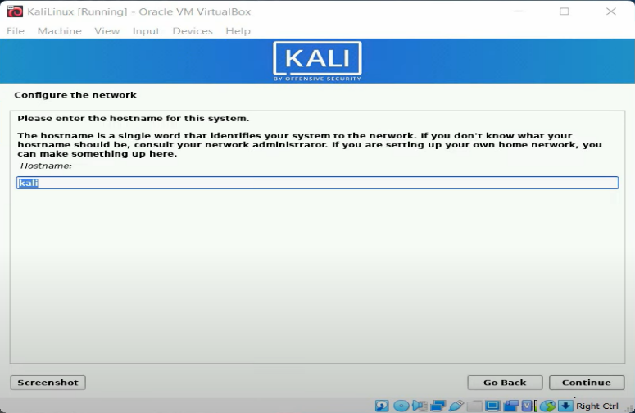

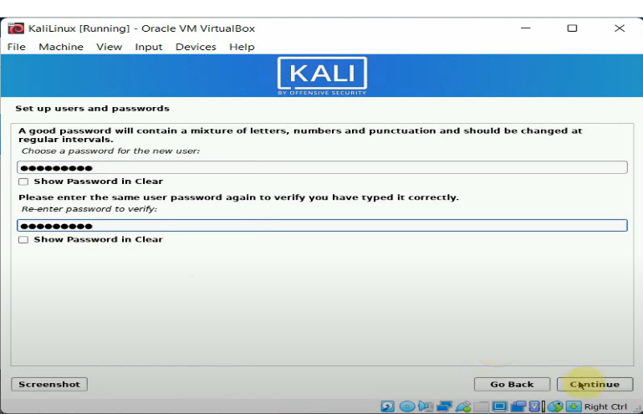

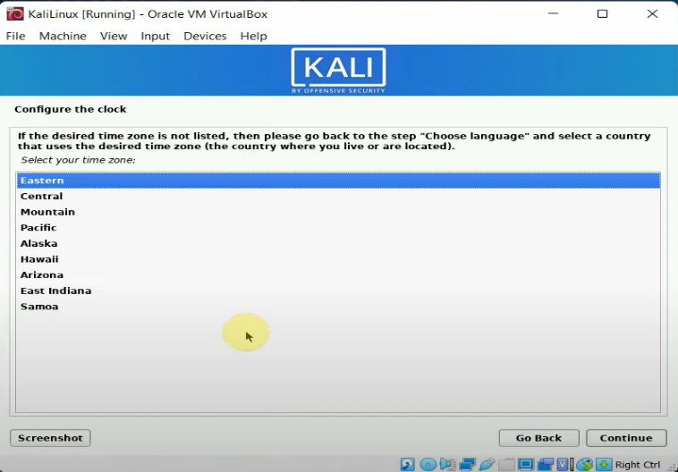

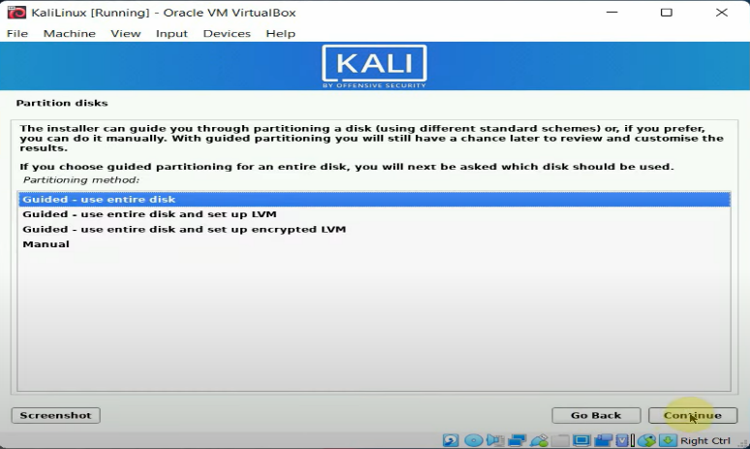

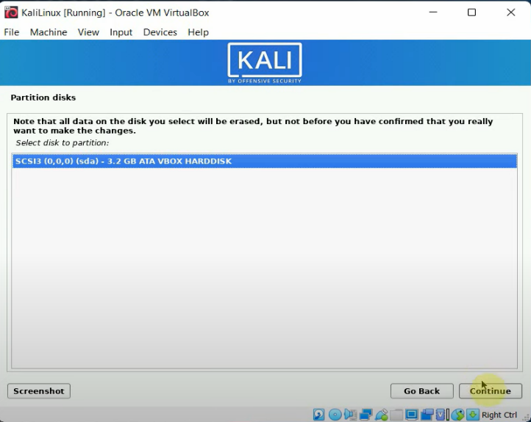

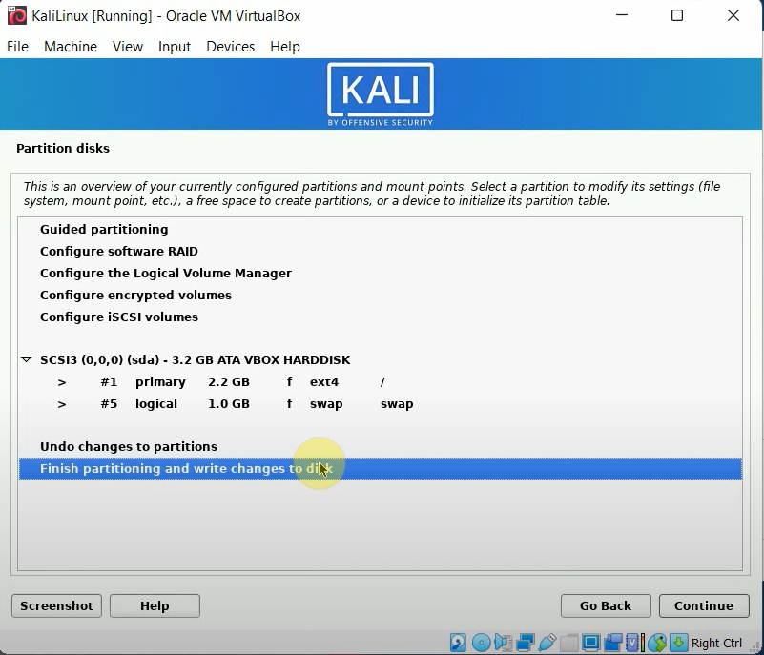

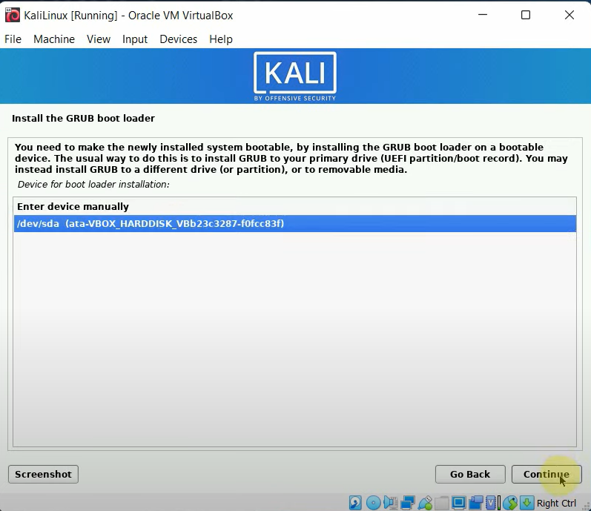

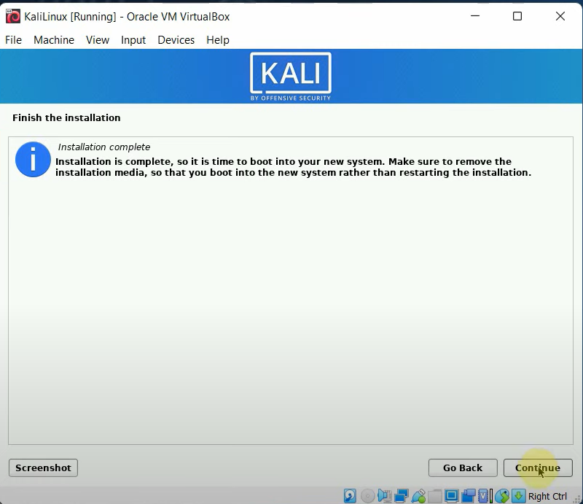

Step 6: Username Kali >Password Kali.

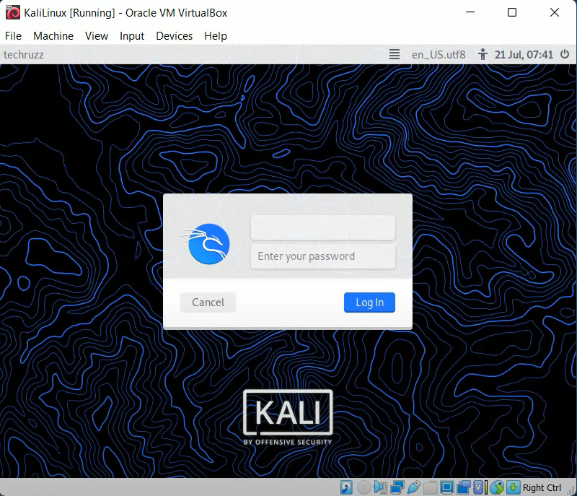

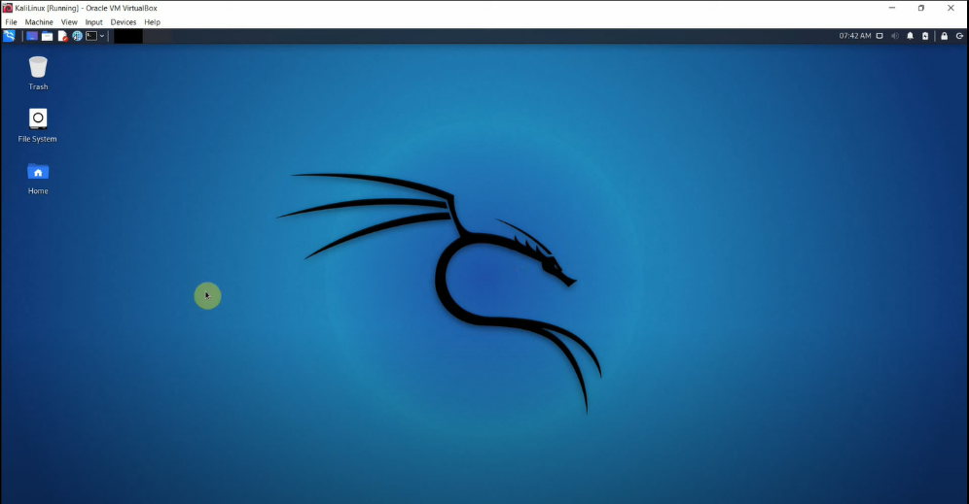

**Practical 2**

**(Exploring the command line arguments)**

1. **Environment Variables, Tab Completion, Bash History Tricks**

* **Environment Variables**

Step 1: Insert export command

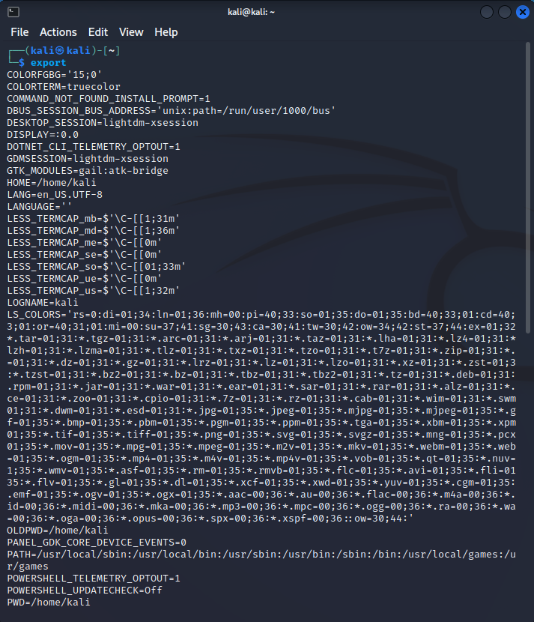

Step 2: Insert command >export kali = 192.168.80.132

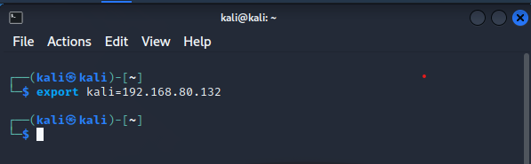

Step 3: Insert command >ping $kali

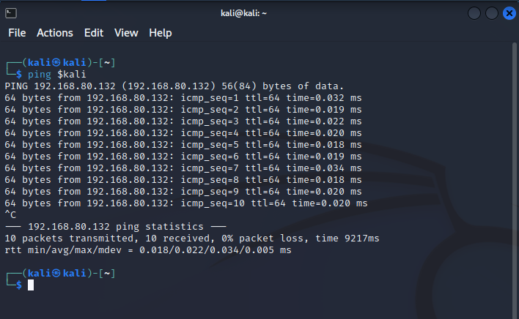

Step 4: Insert command >ping -c 5 $kali

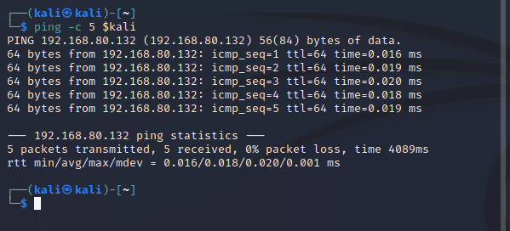

Step 5: Insert command >ping $kalipc = 192.168.80.132

>ping -c 5 $kalipc

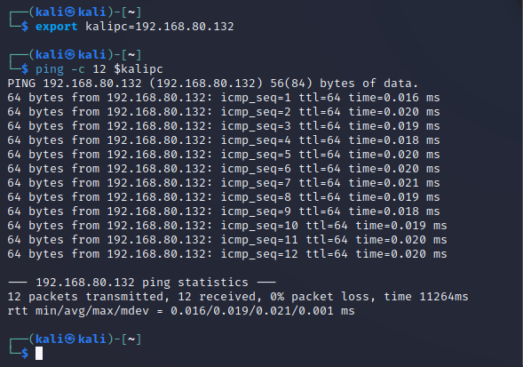

1. **Tab Completion**

Step 1: Insert command >host

>hostname

Step 2: Insert command >ifconfig

Step 8: Insert command >Sudo apt update

* **Bash History**

Step 1: Insert command >history

1. **Piping and Redirection, Text Searching and Manipulation**
2. **Piping & Predirection**

Let's start off by seeing what's in our current directory.

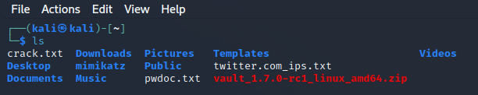

Now we'll run the same command but this time we use the > to tell the terminal to save the output into the file myoutput. You'll notice that we don't need to create the file before saving to it. The terminal will create it automatically if it does not exist.

As you can see, our new file has been created.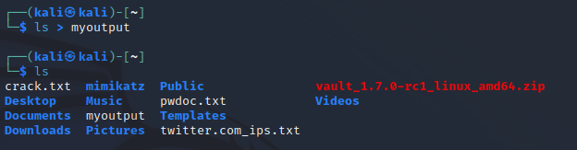Let's have a look at what was saved in there.

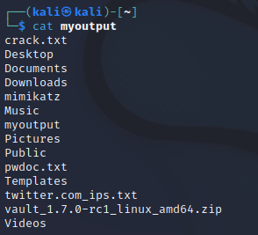

If we redirect to a file which does not exist, it will be created automatically for us. If we save into a file which already exists, however, then it's contents will be cleared, then the new output saved to it.

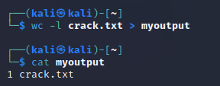

We can instead get the new data to be appended to the file by using the double greater than operator (>>).

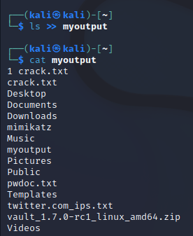

If we use the less than operator (<) then we can send data the other way. We will read data from the file and feed it into. When we ran it redirecting the contents of the file into wc the file name was not printed. This is because whenever we use redirection or piping, the data is sent anonymously.

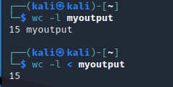

We may easily combine the two forms of redirection we have seen so far into a single command.

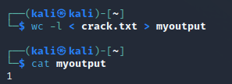

Piping operator does is feed the output from the program on the left as input to the program on the right. We will list only the first 3 files in the directory. we have then piped the output to tail so as to get only the third file.

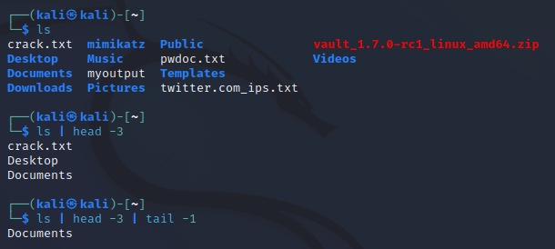

We may combine pipes and redirection too.

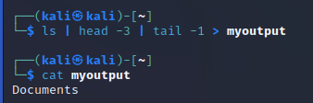

1. **Text Searching & Manipulation**

Step 1: Insert command >cd /home/kali/Desktop

>ls

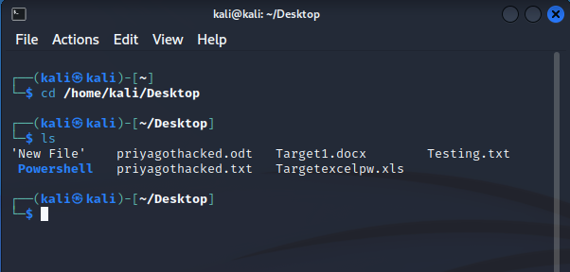

Step 2: Insert command >cat Testing.txt

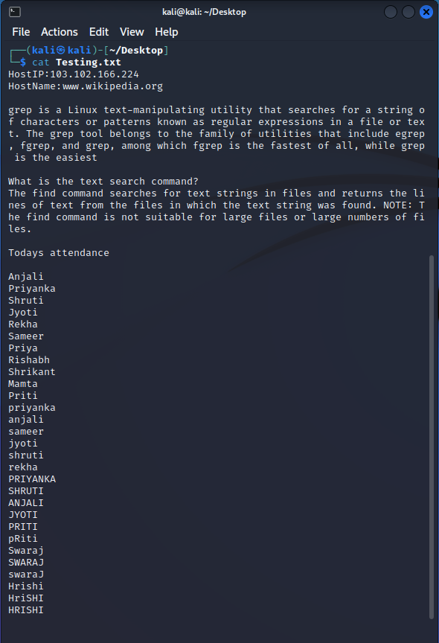

Step 3: Insert command >grep searches Testing.txt

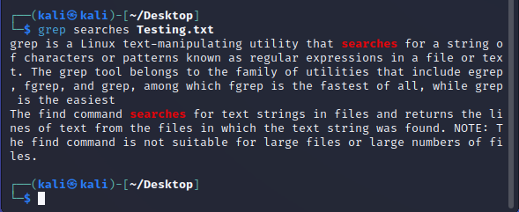

Step 4: Insert command >cat Testing.txt | grep Pri

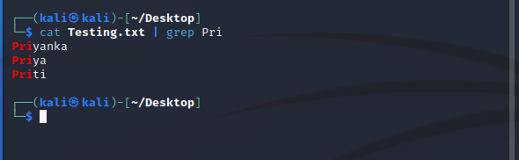

Step 5: Insert command >cat Testing.txt | grep -i “sh”

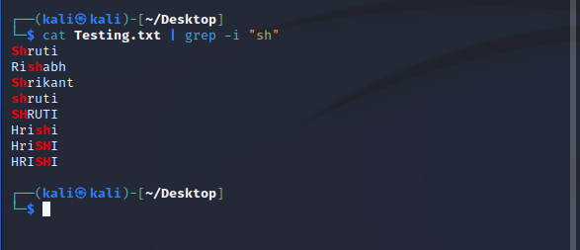

Step 6: Insert command >grep --h

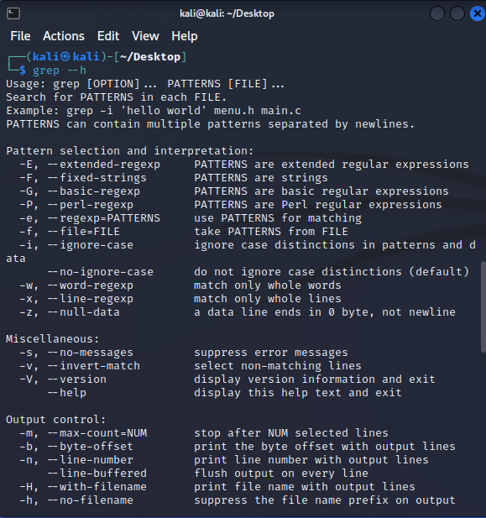

Step 7: Insert command >cat Testing.txt | grep “is”

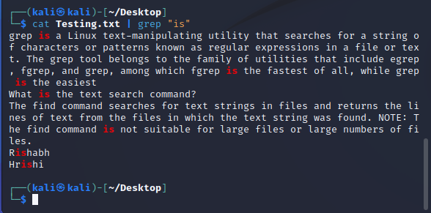

Step 8: Insert command >cat Testing.txt | grep –v “is”

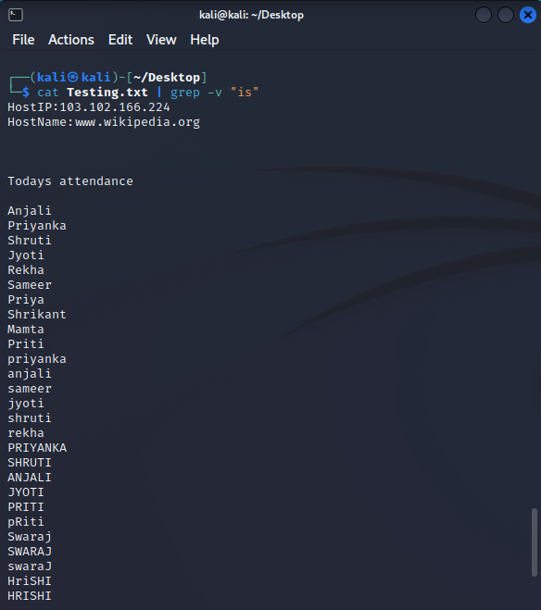

Step 9: Insert command >cat Testing.txt | grep “is\|Pri\|file”

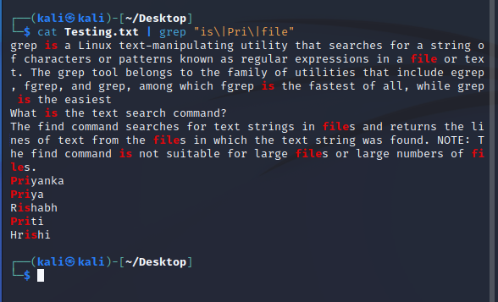

Step 10: Insert command >cat Testing.txt | grep [0-2]

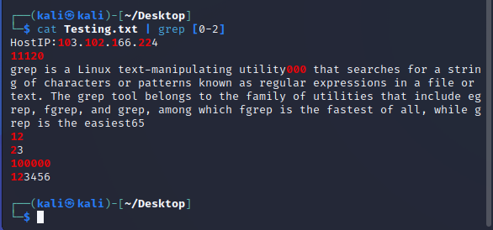

Step 11: Insert command >cat Testing.txt | grep [03-588]

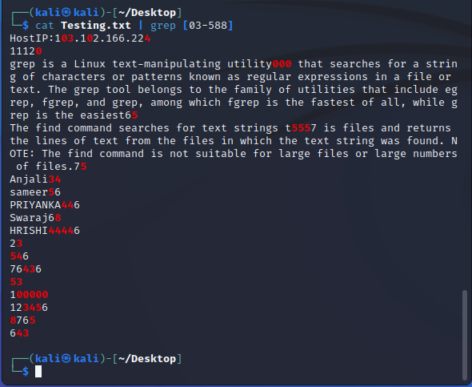

Step 12: Insert command >cat Testing.txt | grep “is”

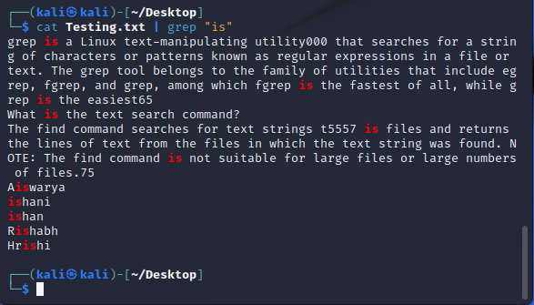

Step 13: Insert command >cat Testing.txt | grep ^is

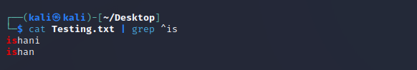

Step 14: Insert command >cat Testing.txt | grep –x “what is the text search command?”

>cat Testing.txt | grep –x “what is”

>cat Testing.txt | grep –x “anjali”

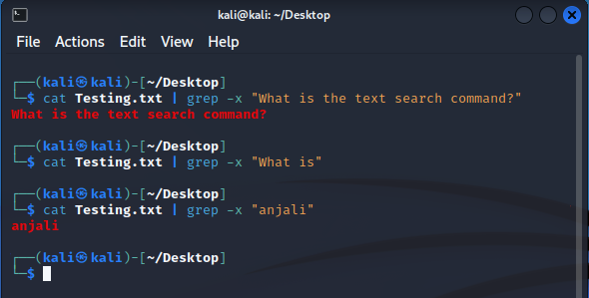

Step 15: Insert command >cat Testing.txt | grep –r “anjali”

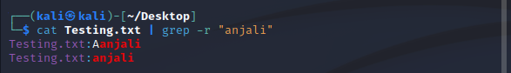

Step 16: Insert command >cat Testing.txt | grep ^a.j

>cat Testing.txt | grep ^a.j

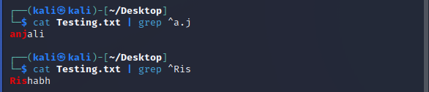

Step 17: Insert command >Cat newfile

>Cat newfile | sed ‘s/any/of/’

>Cat newfile | sed ‘s/any/of/g’

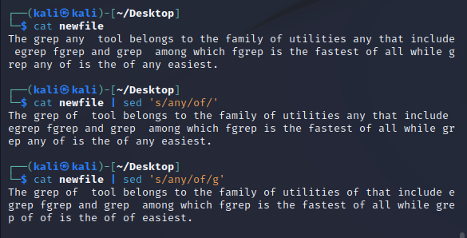

Step 18: Insert command >Cat newfile

>Cat newfile | cut –d “,” –f2

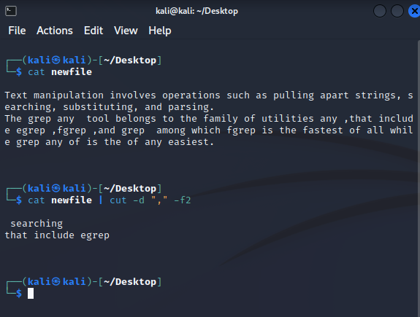

Step 19: Insert command >Date |awk ‘{print $3,$2,$4,$9}’

>Echo “How:are:you:?” | awk –F “:” ‘{print $1,$2,$3,$4}’

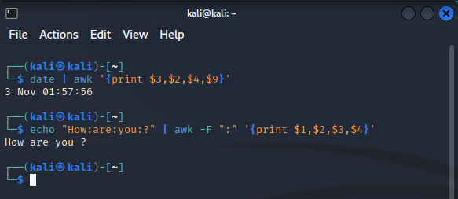

1. **Editing Files from the Command Line, Comparing Files, Managing Processes**

* **Editing Files from the Command Line**

Echo command will add the content to the file redirected.

Step 1: Insert command >cd Desktop

>echo “Hello Everyone” > Sec.txt

>cat Sec.txt

>echo “what's up?” >> Sec.txt

>cat Sec.txt

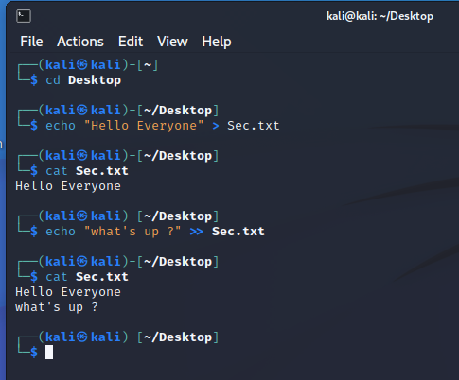

Touch command is to create a File and nano is an editor to add text from command line .

Step 2: Insert command >touch Tool.txt

>nano Tool.txt

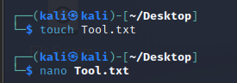

Through command line we can add content to the file we want.

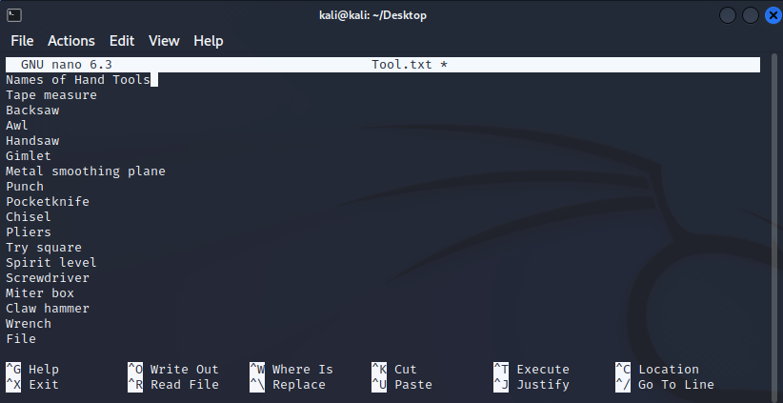

Cat command is to see the entire content of the file.

Step 3: Insert command >cat Tool.txt

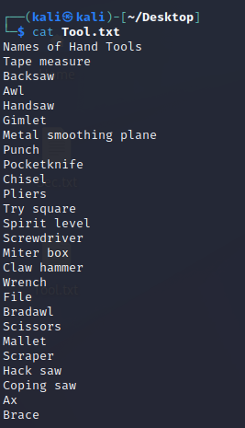

gedit command is use to get a file , after opening it can be edited ,updated or delete things that are to be changed.

Step 4: Insert command >gedit Sec.txt

>cat Sec.txt



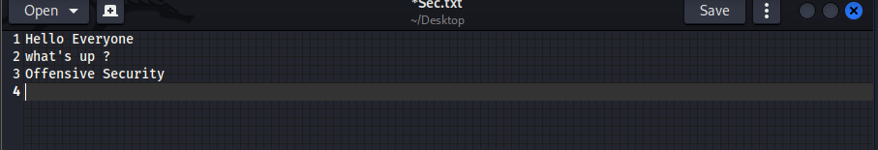

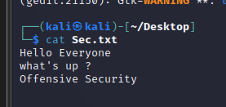

* **Comparing Files**

Step 1: Insert command >ls

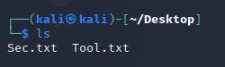

**To check version**

Step 2: Insert command >diff --v

>diff --help

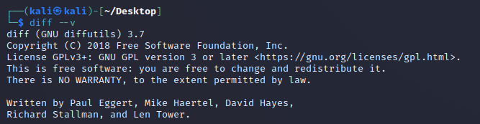

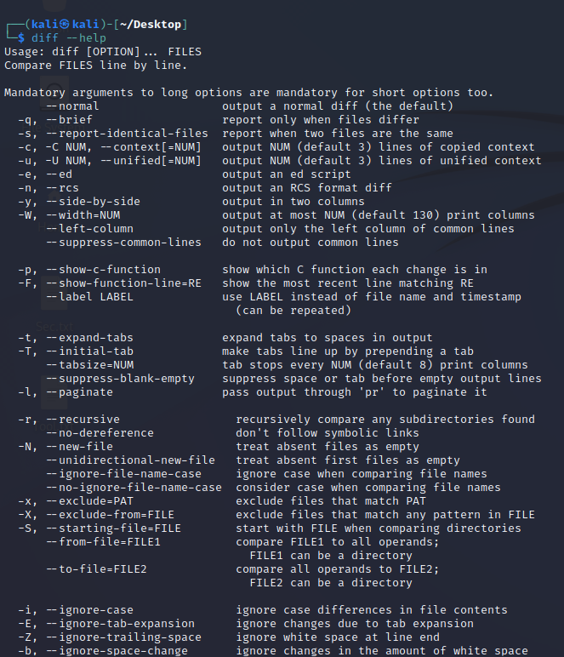

diff stands for difference. This command is used to display the differences in the files by comparing the files line by line.

Diff –-side-by-side Sec.txt Tool.txt is used to compare to files side by side.

Step 3: Insert command >diff --side-by-side Sec.txt Tool.txt

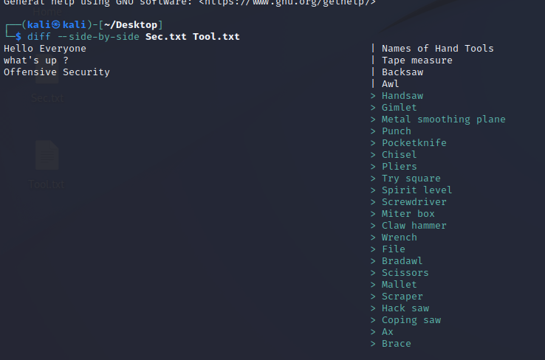

To view differences in context mode, use the -c option

Step 4: Insert command >diff -c Sec.txt Tool.txt

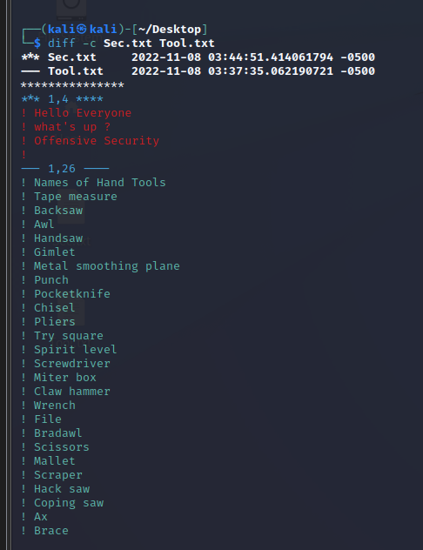

* **Managing Processes**

Step 1: Insert command >nmap -v -T0 hackthissite.org &

>jobs

>fg%1

>nmap -v -T0 hackthissite.org &

Ctrl + B than D (to detached from tmux and go back to original shell)

Step 2: Insert command >tmux

>tmux list-sessions

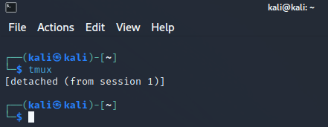

Tmux list-sessions shows sessions that are running

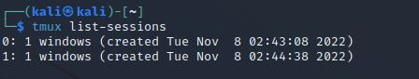

Tmux attach (reattch to the session )

Step 3: Insert command >tmux attach

>nmap -v -T0 hackthissite.org &

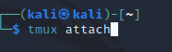 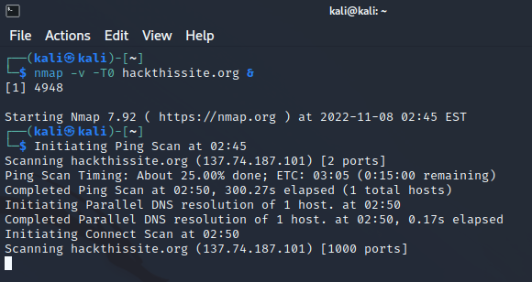

By exit command terminate the kali session, now go to another terminal and type command ps -u kali

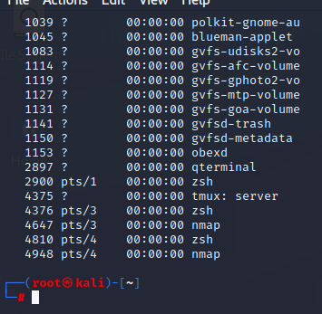

This shows nmap is still running after terminating the kali terminal

Step 4: Insert command >tmux list-sessions

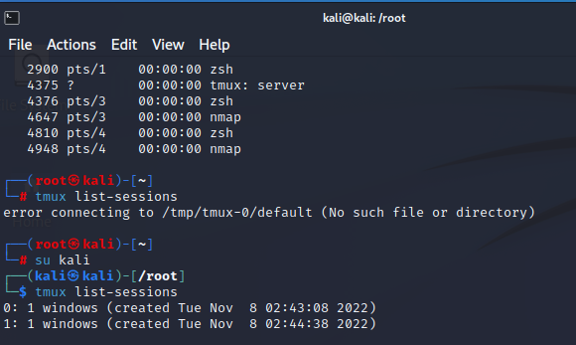

This shoes that still nmap is sunning even though ended kali terminal

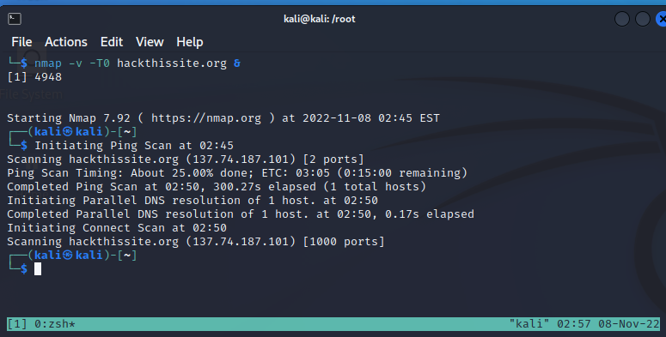

To exit tmux and process running under it click Ctrl + C that will suspend the process than command exit to go root kali.

Step 5: Insert command >tmux attach

>ps -u kali

>nohup map -v -T0 hackthisite.org

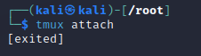

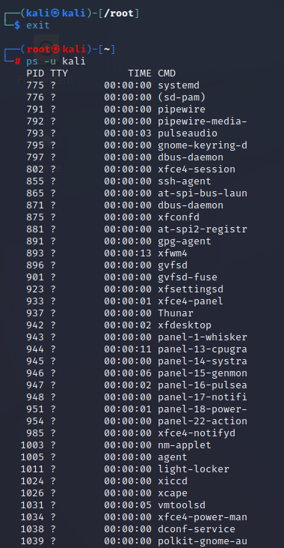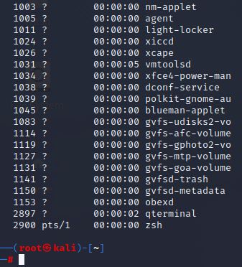

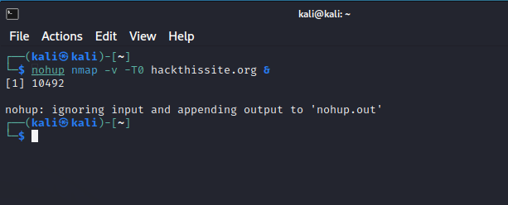

After exiting the terminal and typing ps -u kali command on root kali terminal we will see nmap is still running.

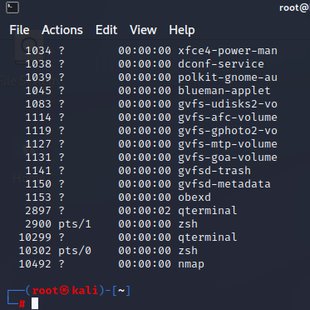

To kill the process type, kill command.

Step 6: Insert command >kill 10492

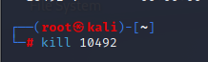

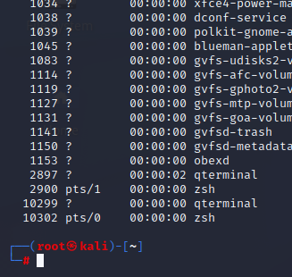

**Practical 3**

* **Using NETCAT Socat**

Step 1: Insert command >sudo apt install netcat-traditional

>nc -h

Step 2: Download Nmap on windows

Direct to that folder in the cmd

Step 3: Insert command >cd C:\Program Files (x86) \Nmap

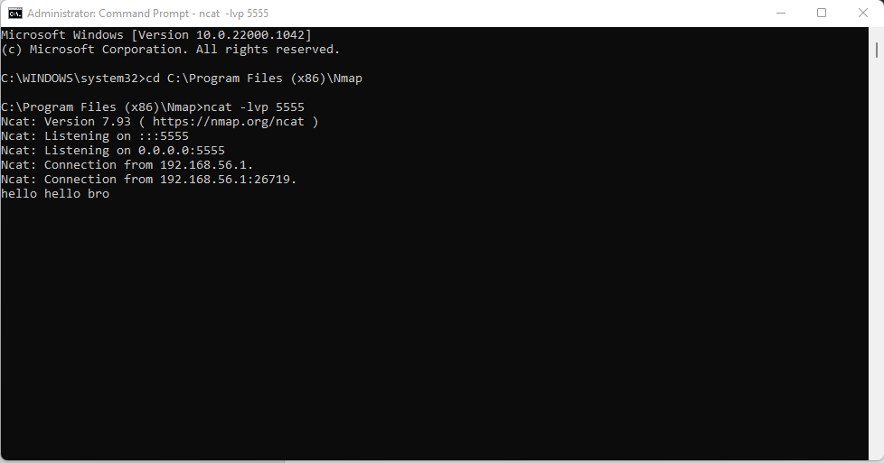

Open kali Linux and open Netcat.

Step 4: Insert command > nc 192.168.56.1 5555 to connect to windows

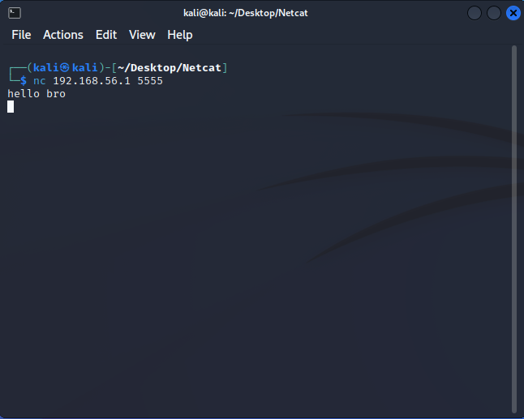

* **PowerShell and Powercat**

Create a folder named powershell in the desktop and click on open terminal here

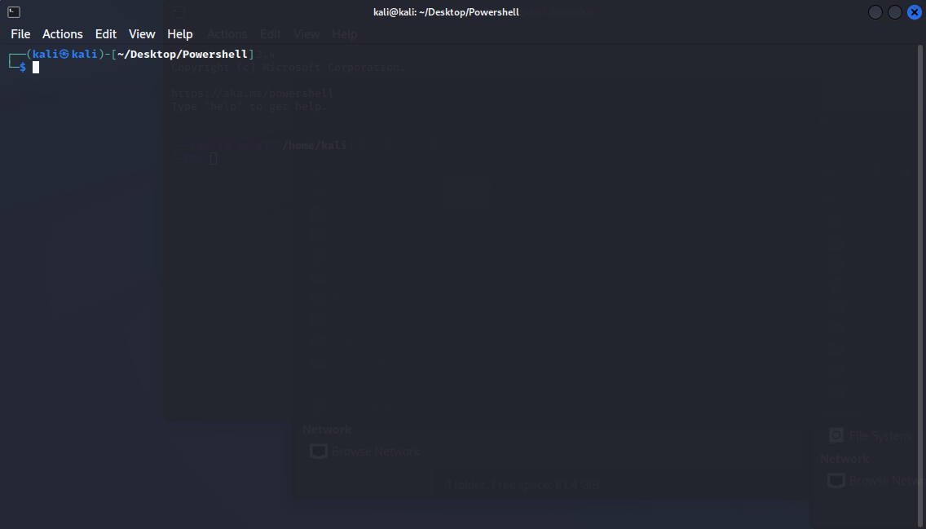

Step 1: Insert command >sudo apt install powercat

Step 2: Insert command >sudo apt install python2

Step 3: Insert command >python2 –m SimpleHTTPServer 80

Open terminal.

Step 4: Insert command >nc –vlp 4444

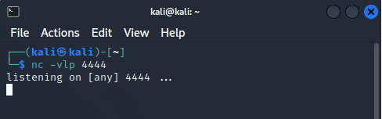

* **Wireshark and Tcpdump**

Step 1: Insert command >sudo –i

Step 2: Insert command >tcpdump -D

Step 3: Insert command >tcpdump –i eth0

Step 4: Insert command >tcpdump –c 5 -i eth0

Step 5: Insert command >tcpdump –c 5 -i eth0 -n

Step 6: Insert command >tcpdump –c 10 -i eth0 port 443

Step 7: Insert command >tcpdump –c 10 -i eth0 –w helpanjali

>tcpdump –r helpanjali

Step 8: Open Wireshark. Try capturing from eth0 the network from “TCP” protocol.

**PRACTICAL 4**

**a. Whois Enumeration**

Step1: Open Browser > Search Whois > Enter >

             > Search about any website

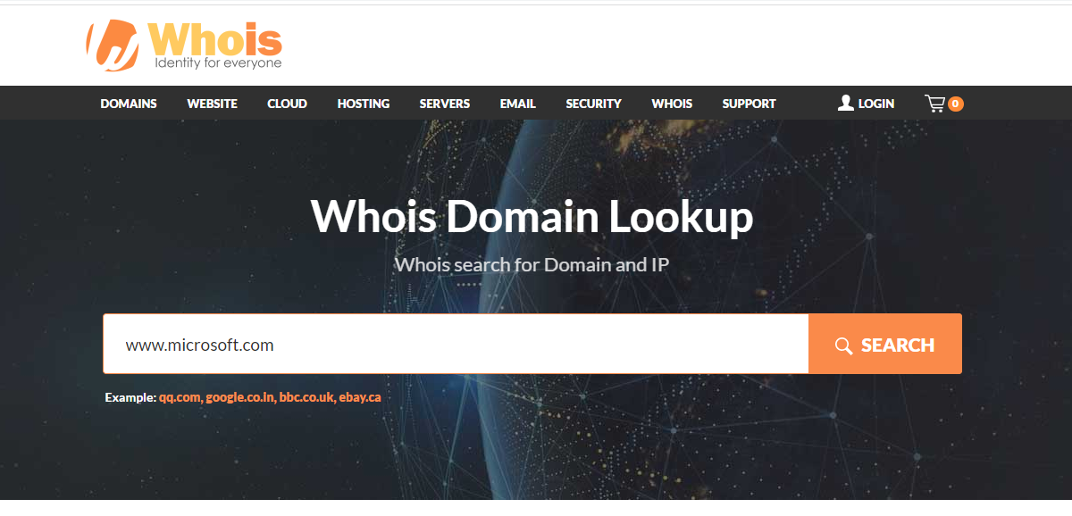

Step 2: Output

**b. Netcraft, Recon-ng, Shodan**

* **Netcraft**

Step 1: Open mozzila firefox and go to <https://sitereport.netcraft.com> .

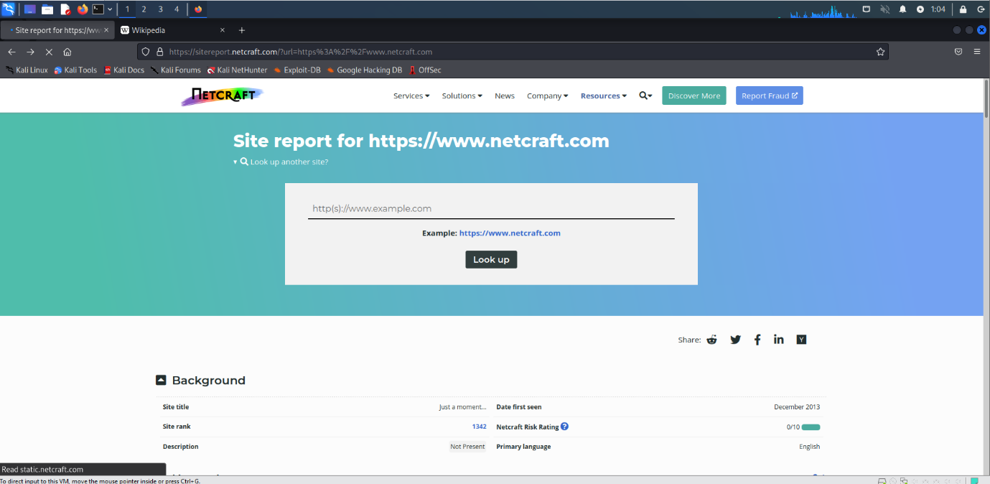

Step 2: Type <https://www.wikipedia.org> and click on “Look up” button

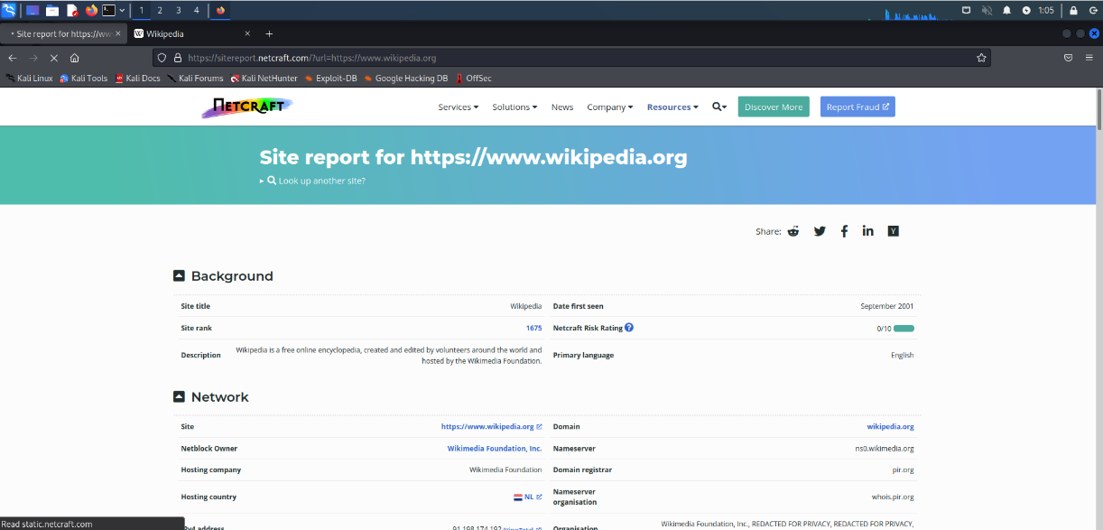

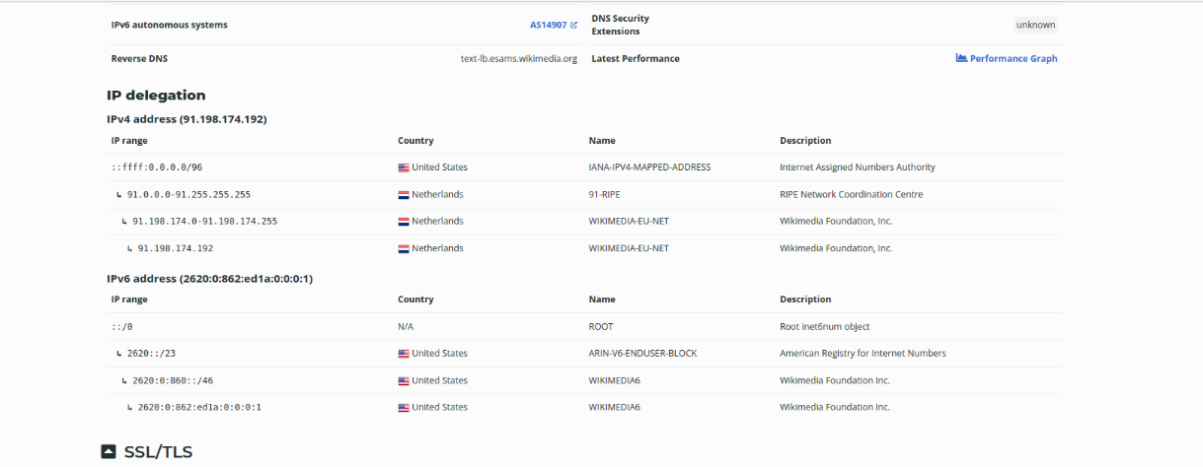

Step 3: Hosting History to see owner details,

* **RECON-NG**

Step 1: Insert command >Recon-ng

Step 2: Install modules from the Marketplace

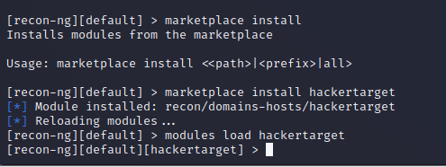

Step: 3 Insert command>**options set SOURCE tesla.com**

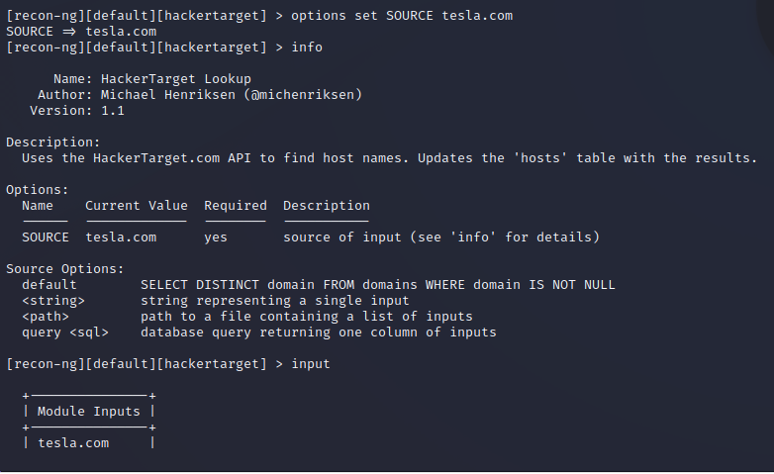

Step 4:Insert command> Run

Step 5: Insert command> marketplace Search

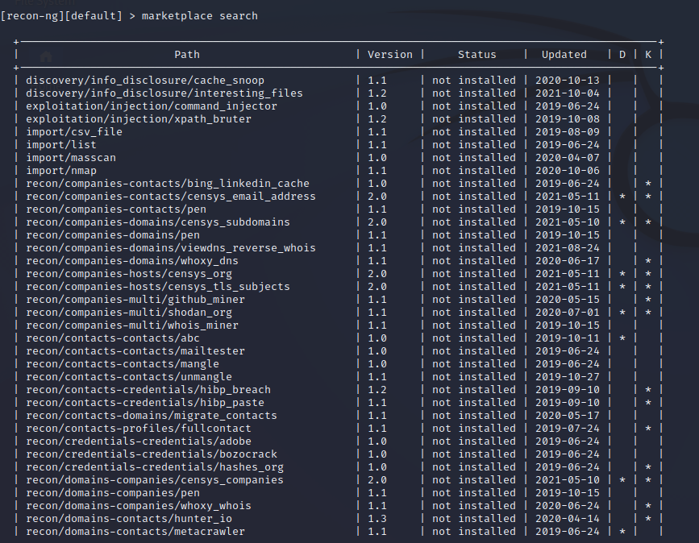

Step 6: Insert command> modules load hackertarget

             > help

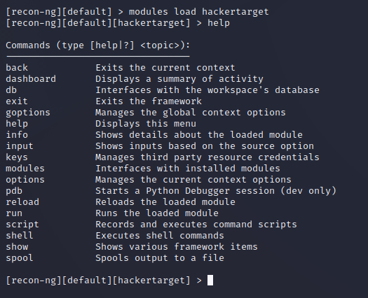

* **SHODAN**

Step 1: Insert command> modules Open mozzila firefox. Search <https://www.shodan.io/dashboard>

Step 2: modules Search “webcam” on search bar.

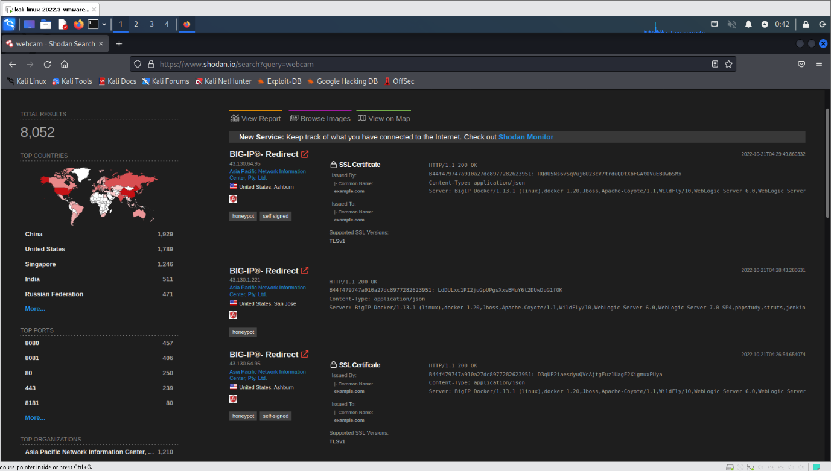

Step 3: modules Search “129.226.36.183” on search bar. And see if there any Open Ports on it.

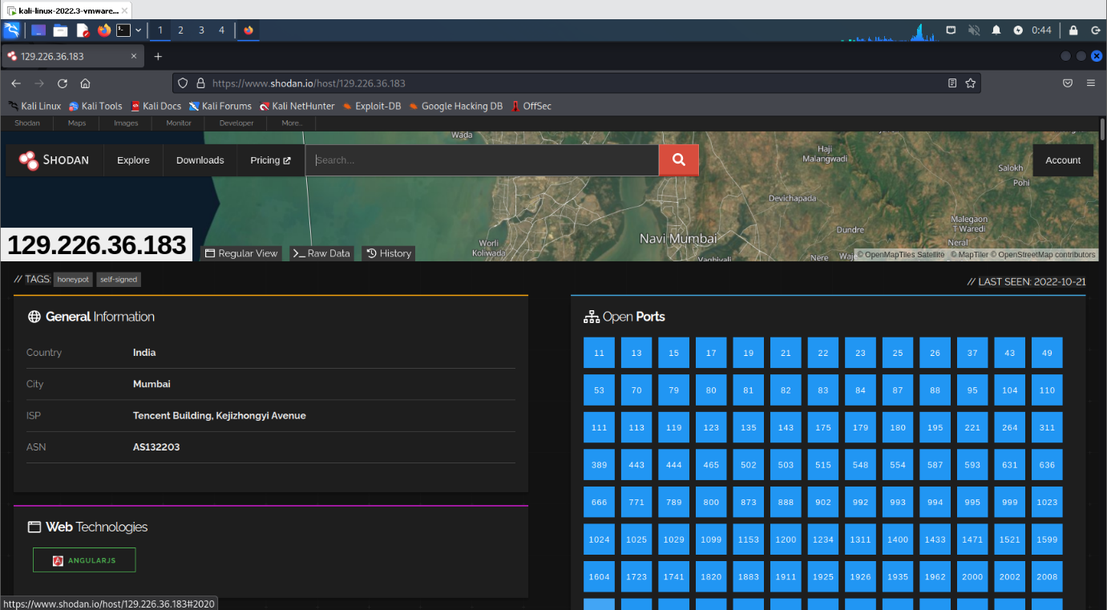

Step 4: modules Select the preferred network. And try access it.

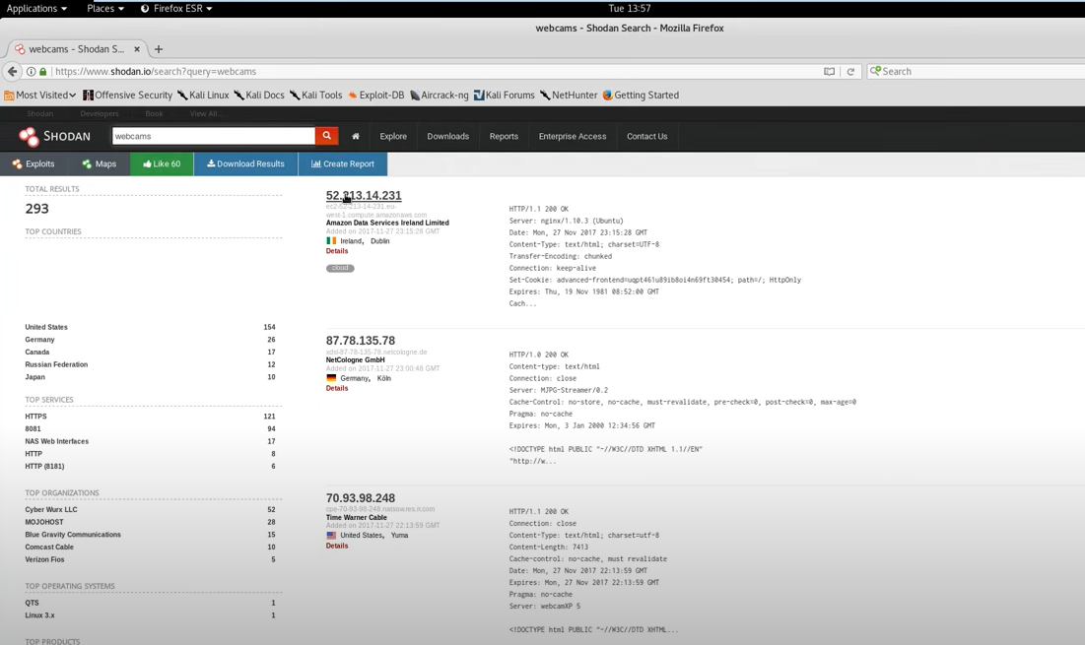

Step 5: modules Open 52.213.14.231:443 . LookCameras to see the free camera view from the locality.

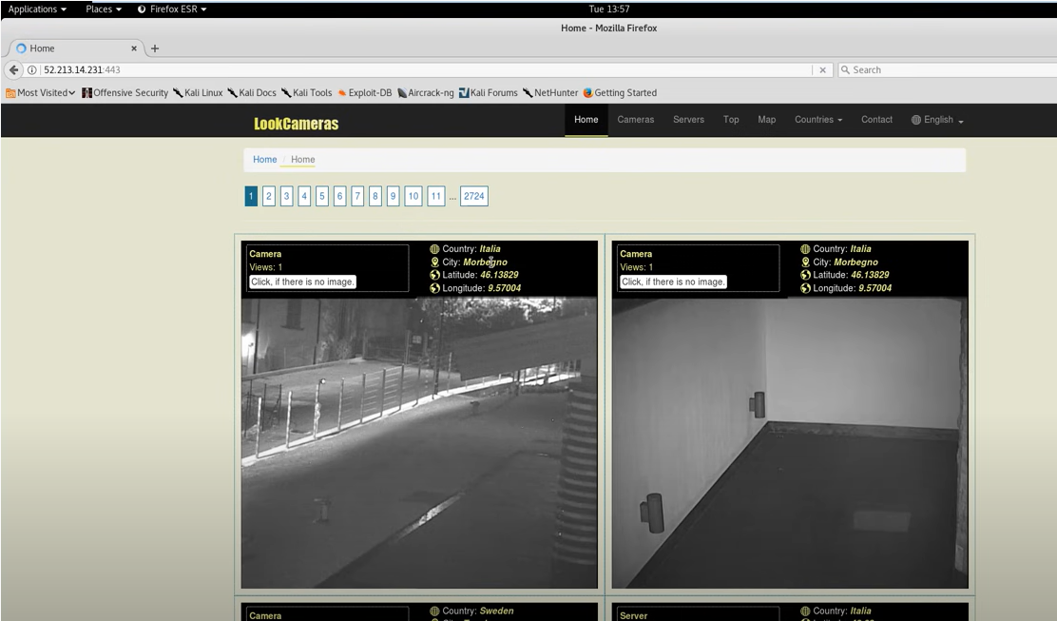

Step 6: modules We can also get access of nearby cameras, by this website “WEBCAMXP 5”.

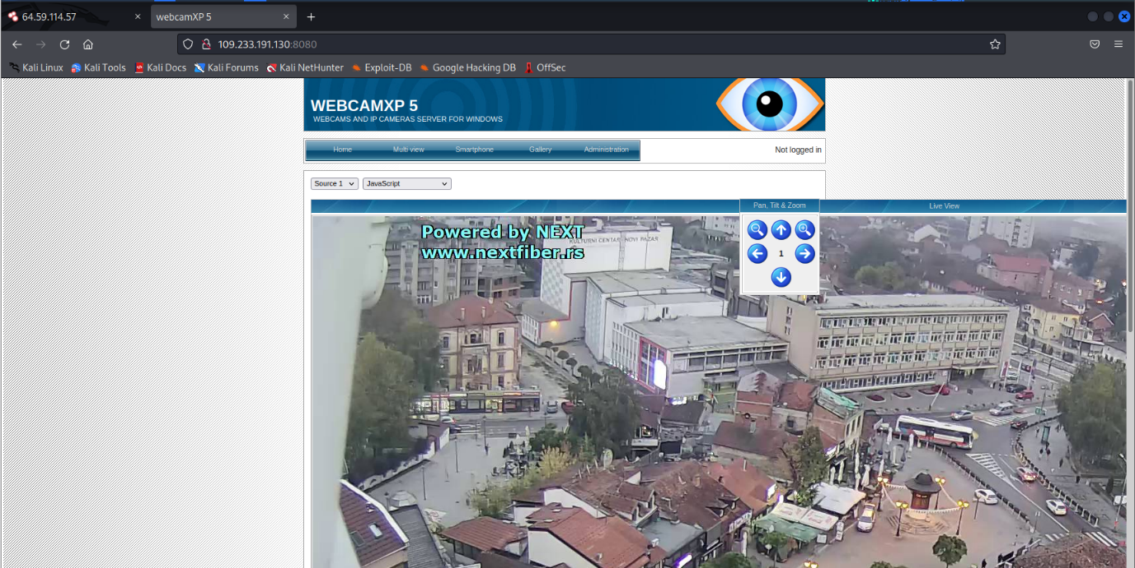

Step 7: modules We can search city open cameras by searching city:“mumbai”

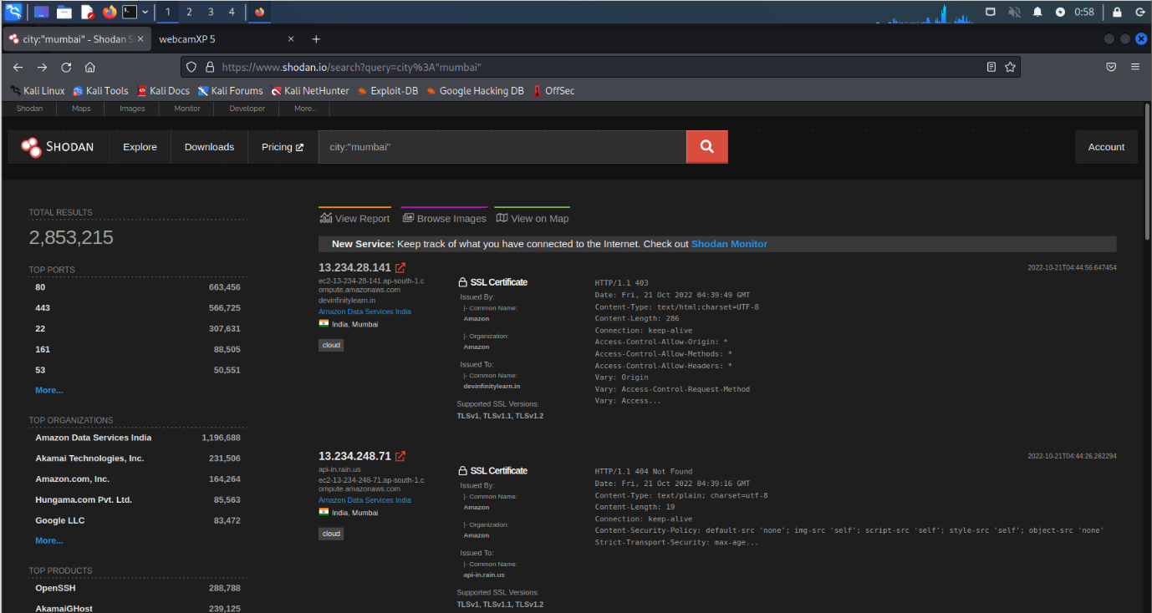

Step 8: Insert command>modules pip install –U –user shodan

>shodan

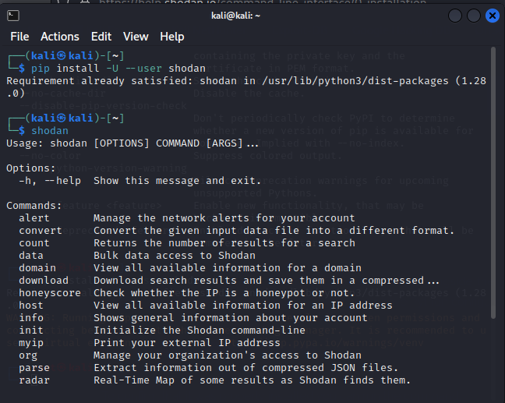

After successfully installation of shodan .Enter Account API key

Step 9: Insert command> modules shodan init <API key>

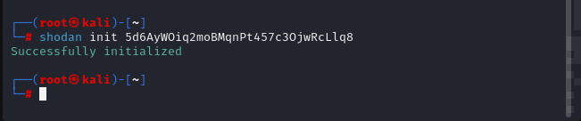

Step 10: Enter the host ip address to get information.

Insert command> modules shodan host 189.201.128.250

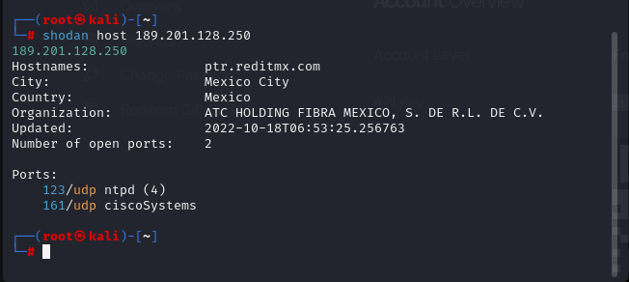

**PRACTICAL 5**

**(User Information Gathering)**

1. **Email Harvesting**

Step 1: Insert Command> sudo theHarvester --help

Step 2: Insert Command> sudo theHarvester –d geeksforgeeks.org –b bing

Step 3: Insert Command> sudo theHarvester –d bbc.com –l 200 –b google

1. **Information Gathering Frameworks- OSINT Framework**

Step 1: Search <https://osintframework.com/>

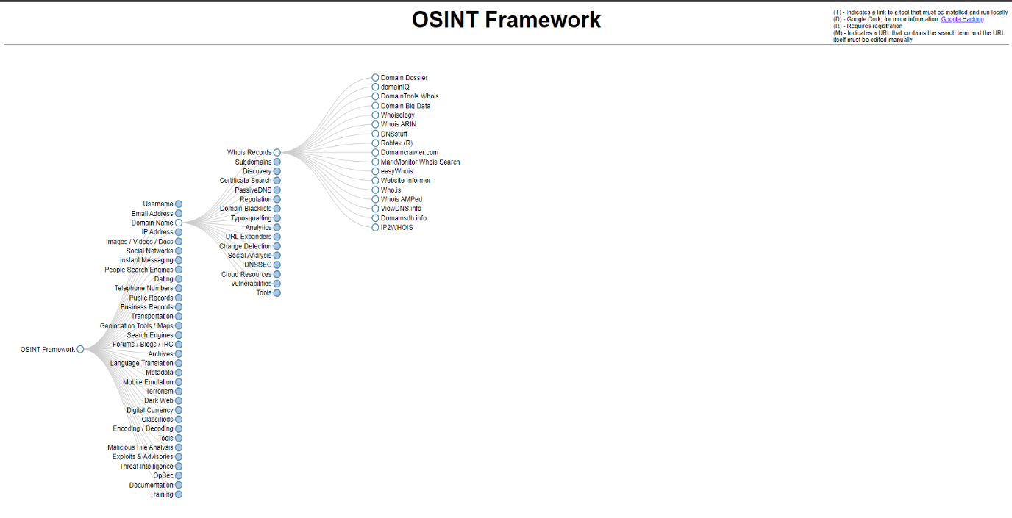

Step 2: Choose Domain name>Whois Records>Who.is

Step 3: Insert <http://certifiedhacker.com/> to search the detailed information about it.

We get its Registrar Info, its Important dates, Name servers, domains,etc.

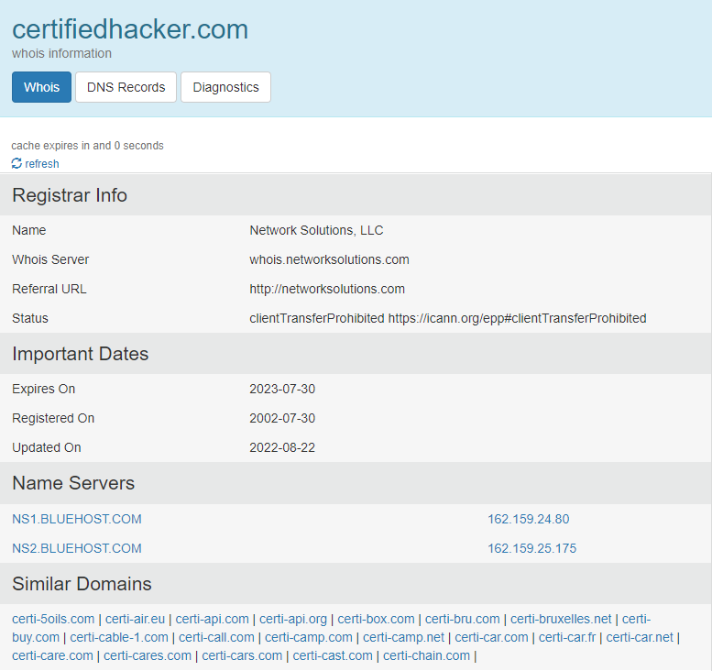

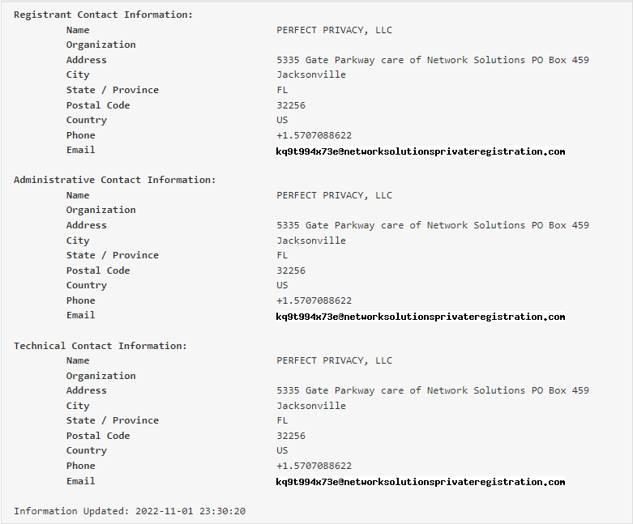

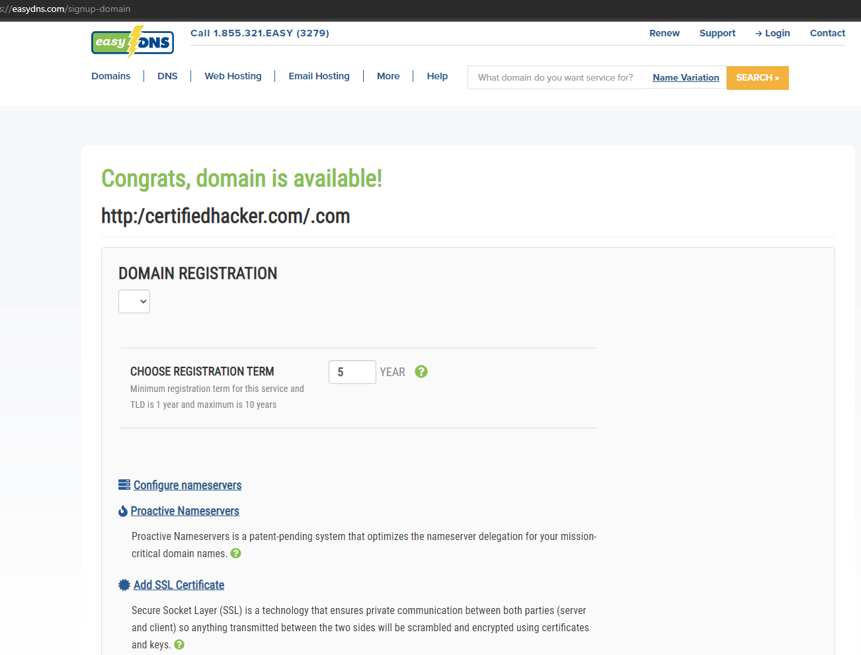

Accessing the Deep Web Details using OSINT Framework

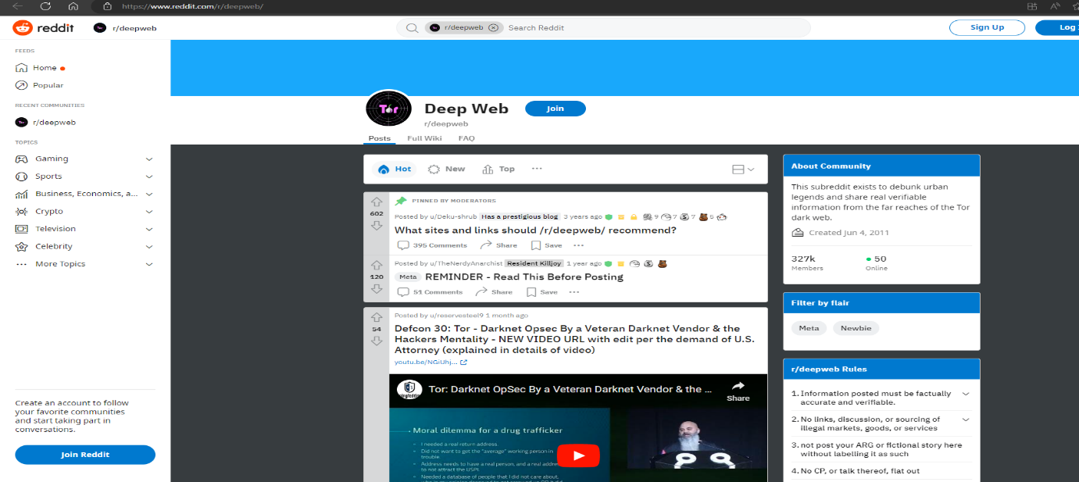

Accessing the AHMIA Software/Website using OSINT Framework.

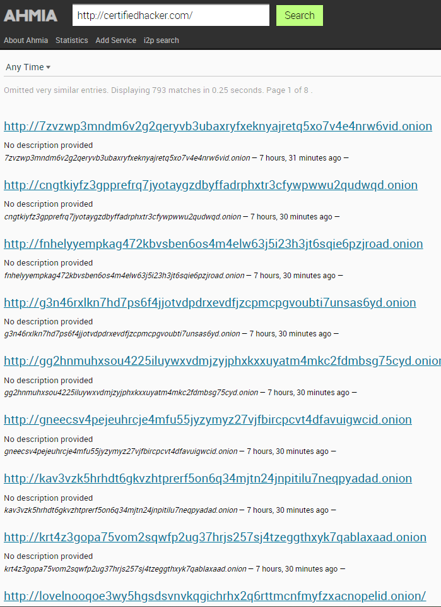

**PRACTICAL 6**

**(Active Information Gathering)**

1. **DNS Enumeration**

Step 1: Open Kali Linux

Step 2: Click on Usual Applications >01-Information Gathering > DNS Analysis > dnsenum

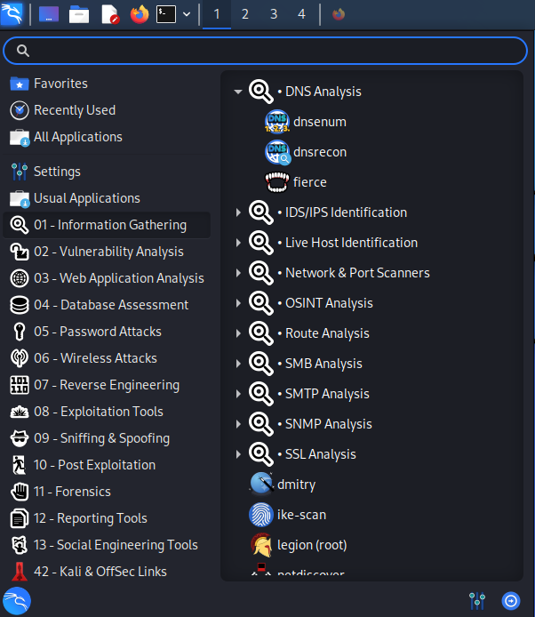

Step 3: Insert Command>dnsenum -h

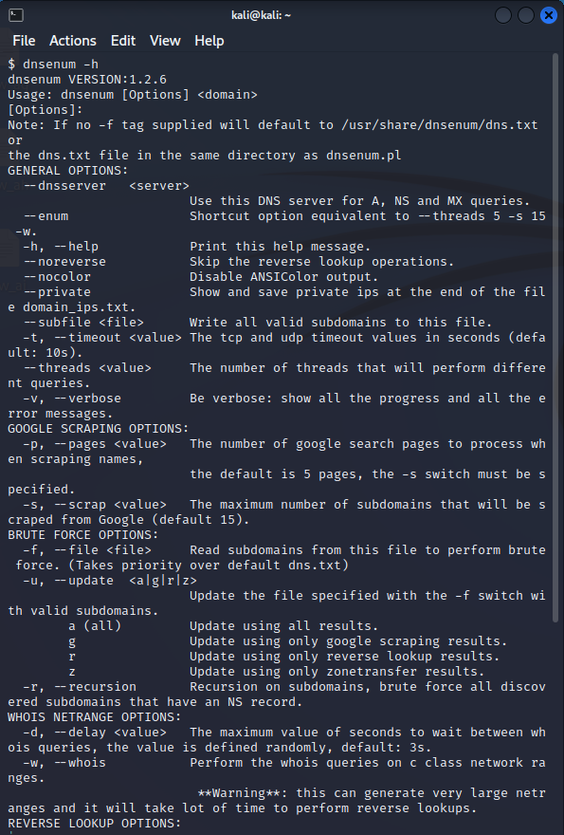

Step 4: Insert Command> dnsenum –dnsserver 8.8.8.8 twitter.com

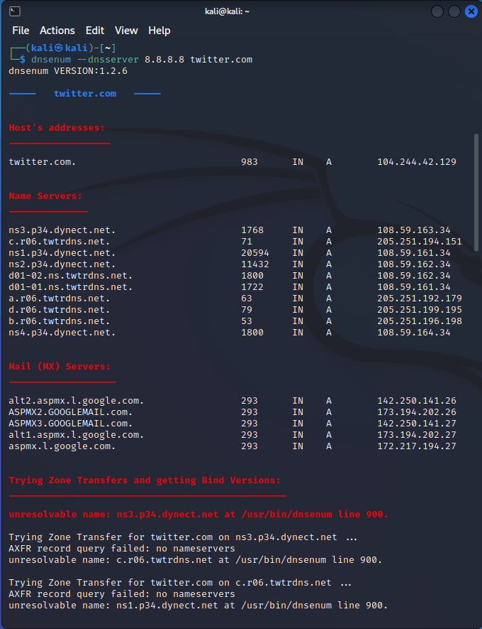

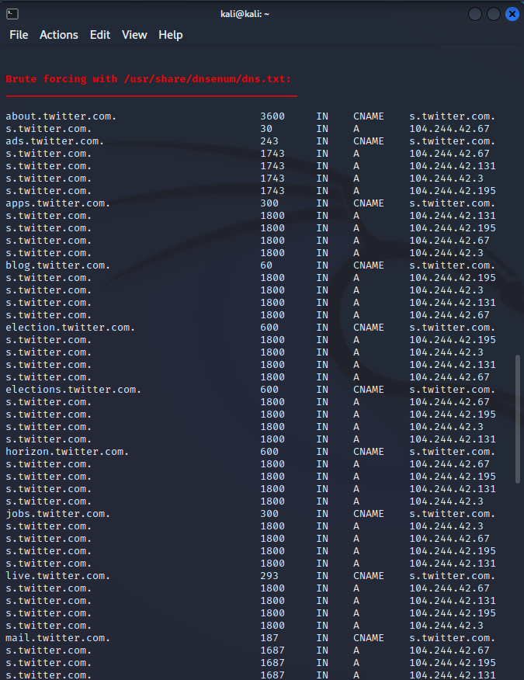

**PRACTICAL 7**

**(Vulnerability Scanning)**

1. **Vulnerability Scanning with Nessus**

Step 1: Search and Download Nessus for windows

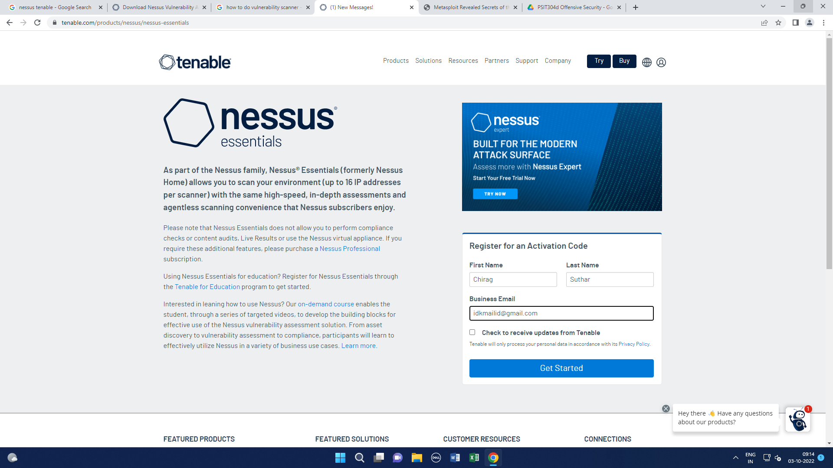



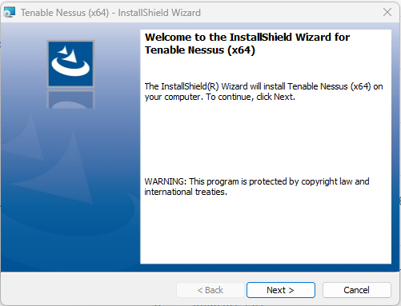

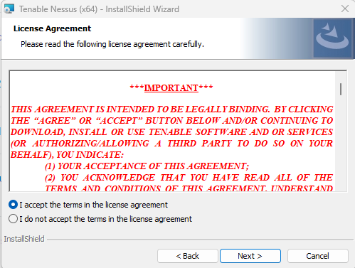 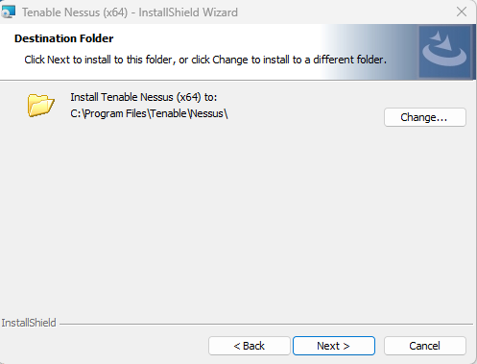

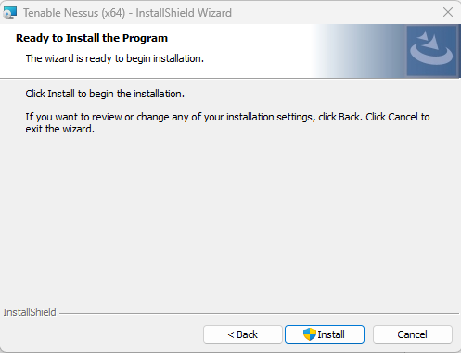 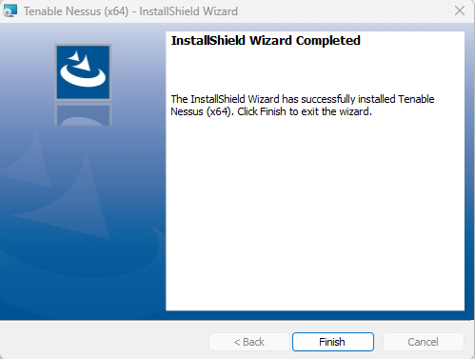

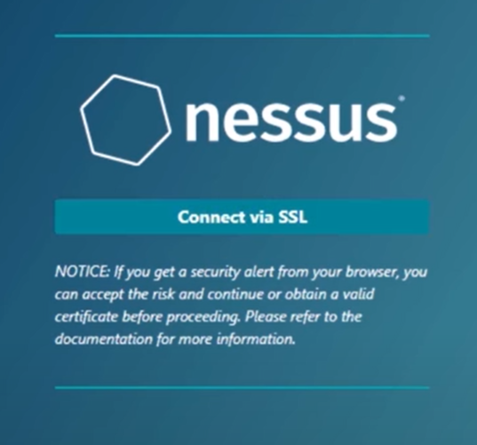 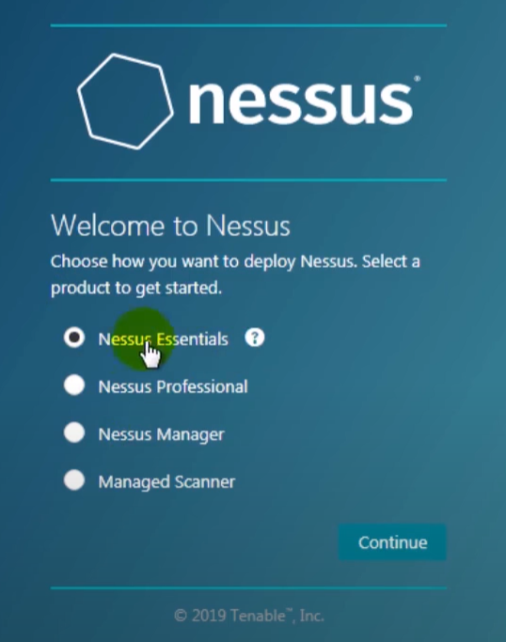

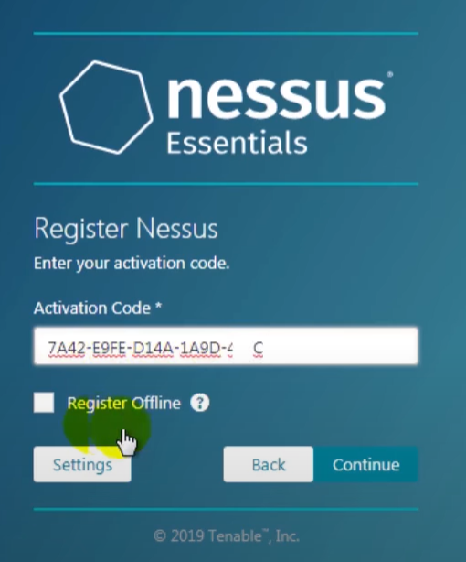

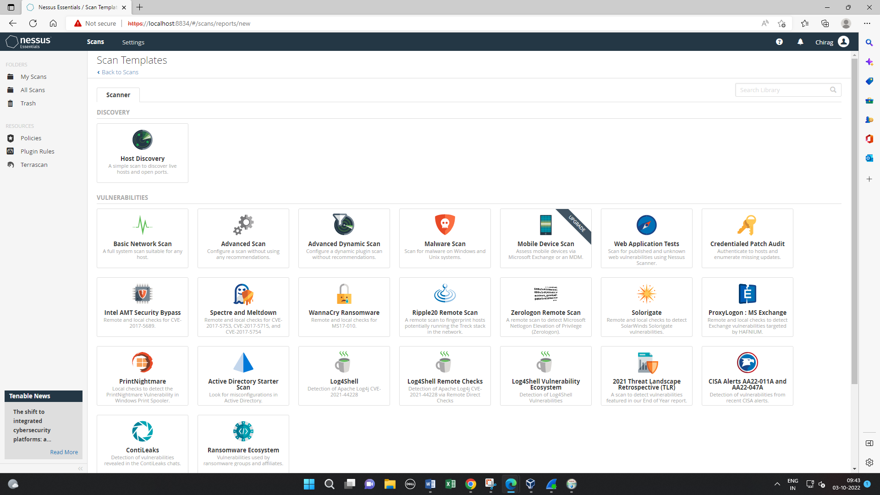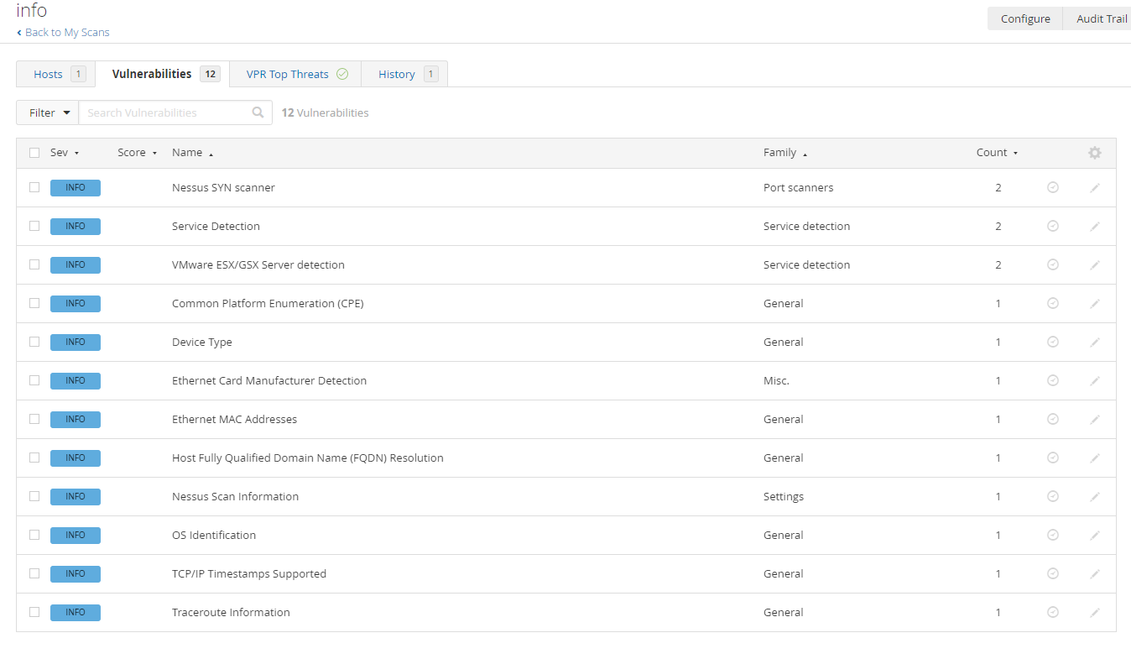

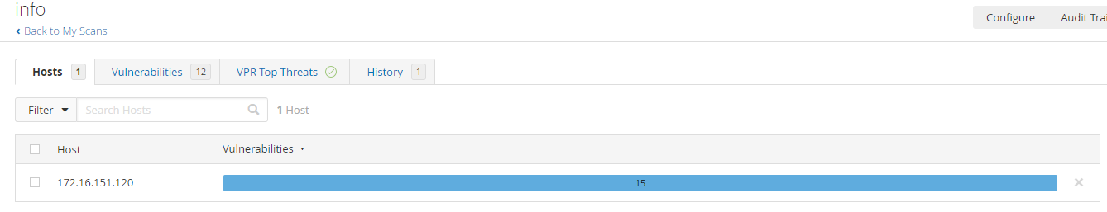

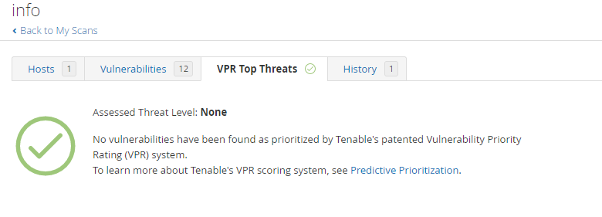

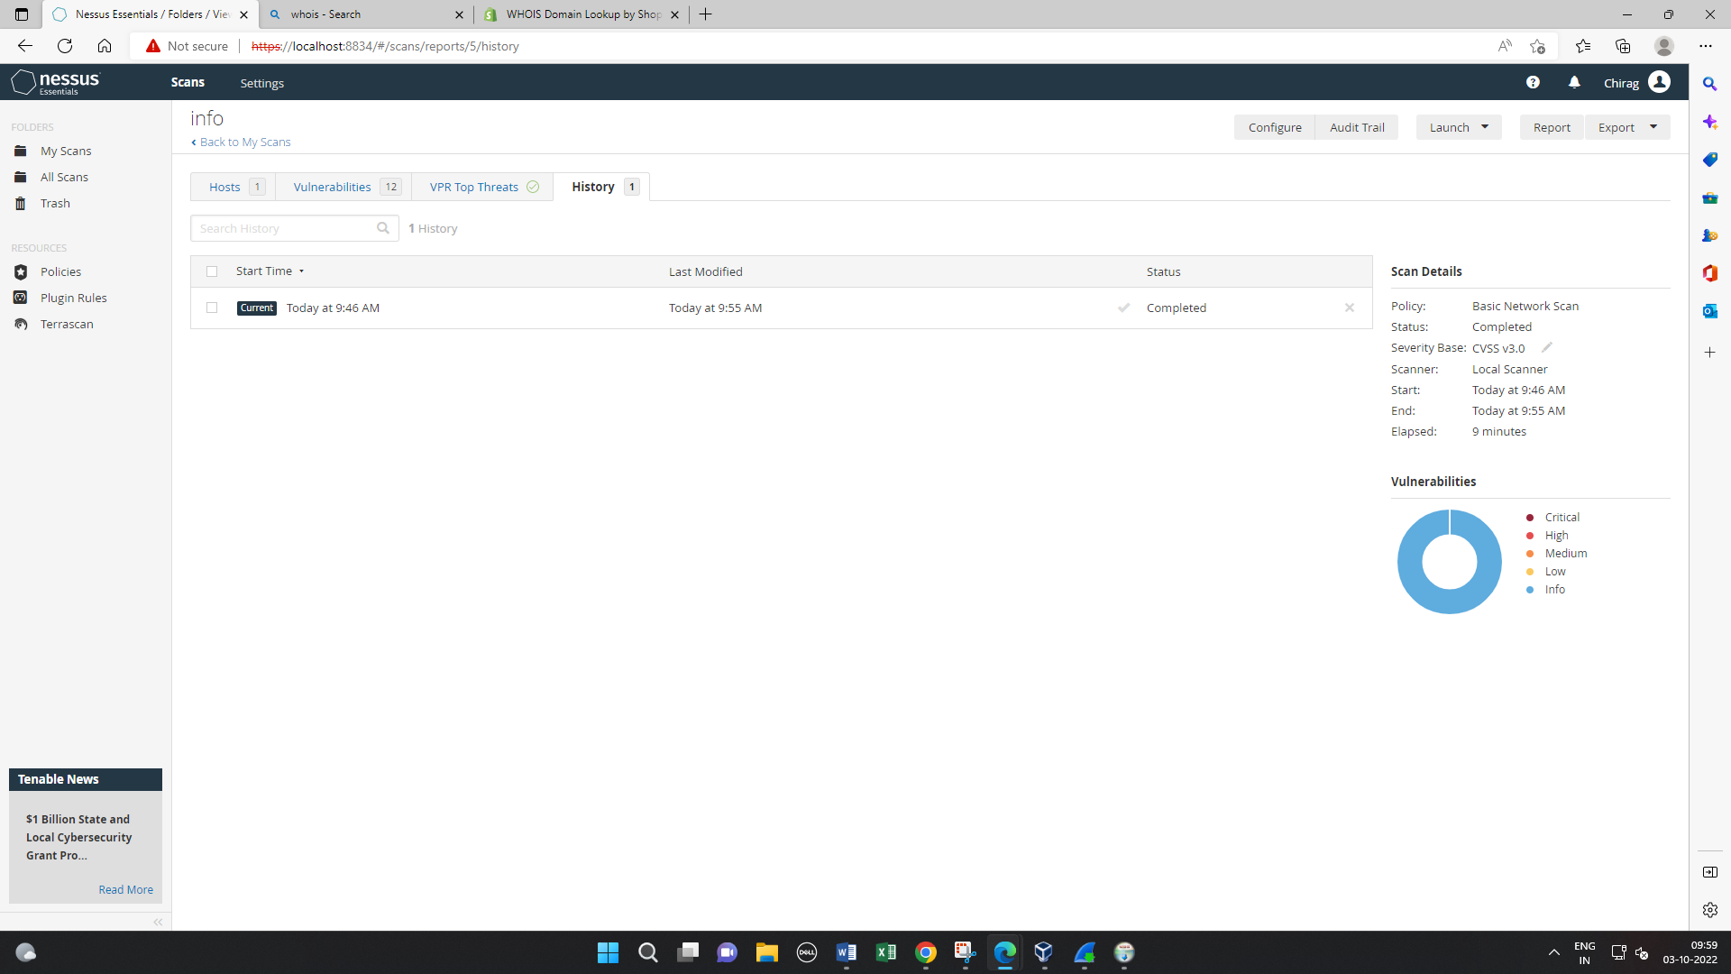

1. **Vulnerability Scanning with Nmap**

Step 1: Open Cmd

To trace the network or ports enter the trace Command with any website

Step 2: Insert Command> *C:\Users\Admin> tracert www.google.com*

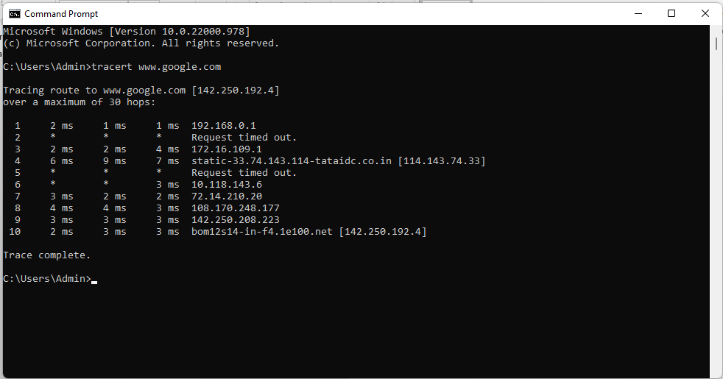

Step 3: Download and Install the Nmap

Step 4: Enter the IP Address on Nmap, in the Target profile tag select the intense scan. After this Step we will get Nmap Output.

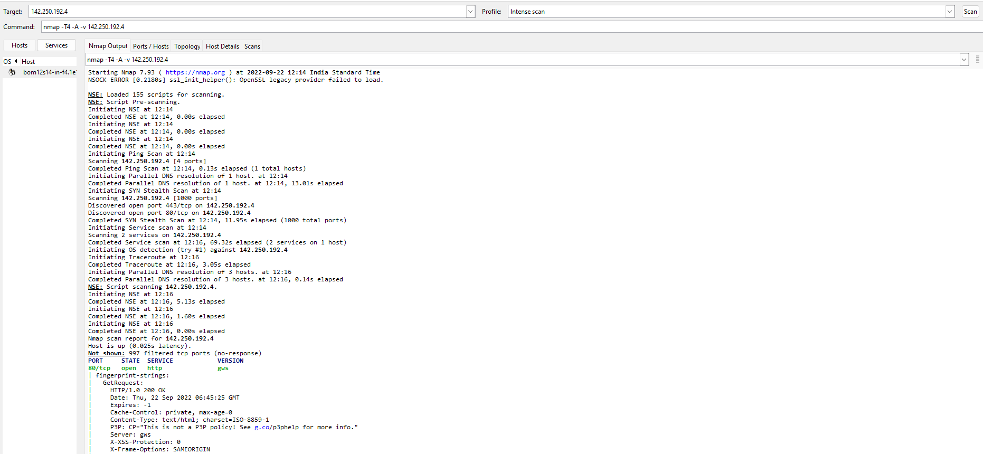

Step 5: Scanned and connected ports

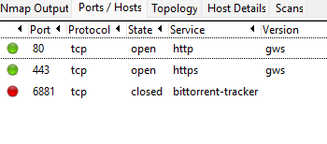

Step 6: Scanned and Connected Topology

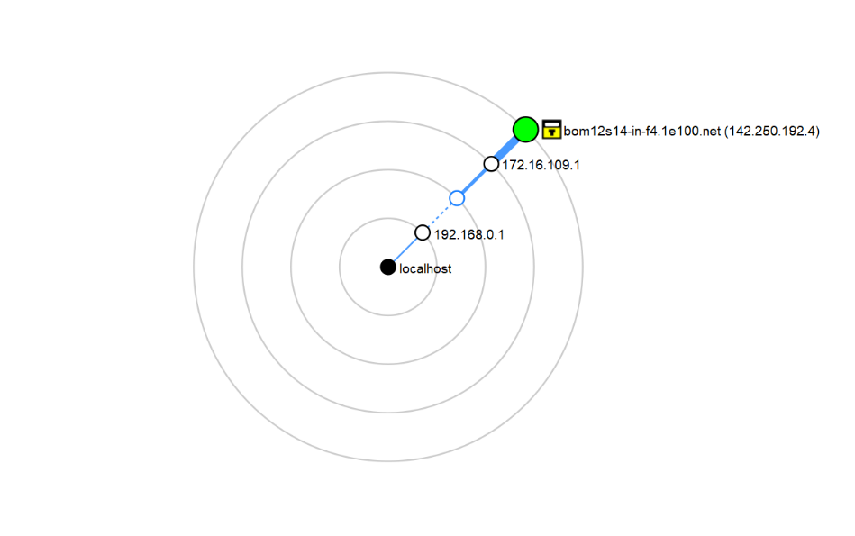

Step 7: Connected Host Details.

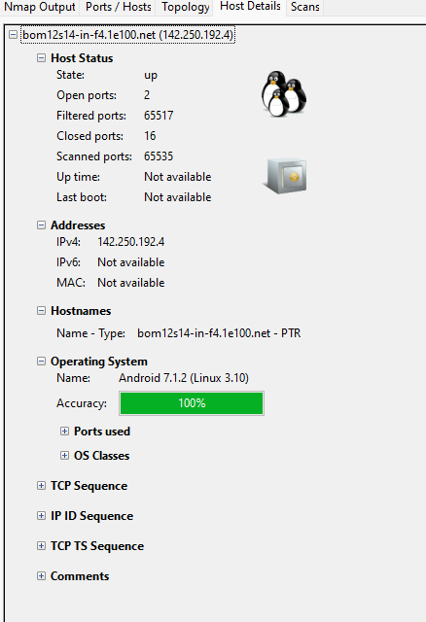

**PRACTICAL 8**

**(Web Application Assessment Tools)**

1. **DIRB**

Step 1: Download dirb tool from Mozilla firefox <https://www.secuneus.com/dirb-tool/>.

Step 2: Insert Command>dirb

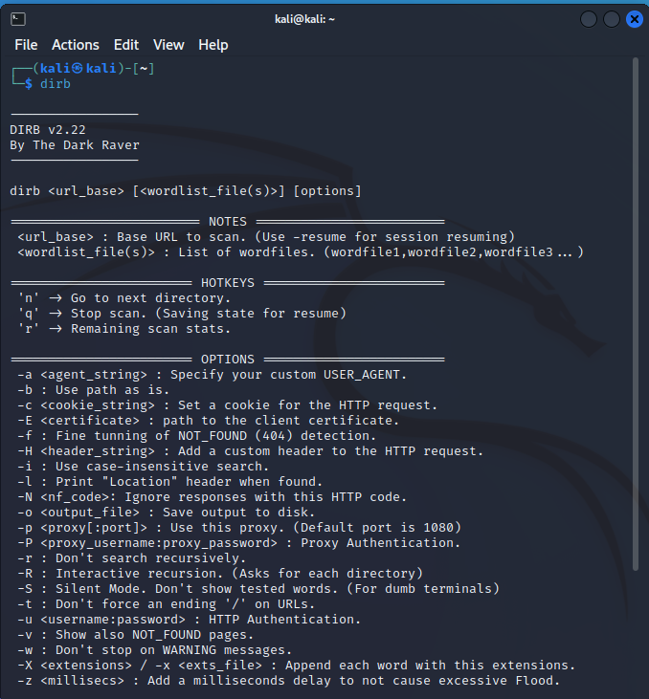

Step 3: Using **locate dirb** command take the path of wordlist from it:

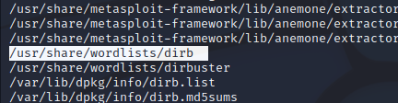

Step 4: Insert Command>ls -l -a

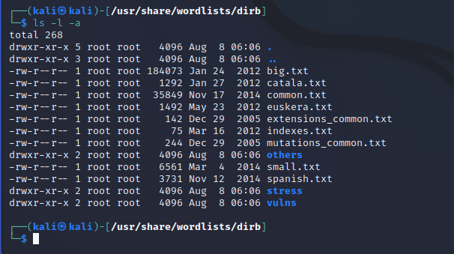

Step 5: Insert Command> cd vulns

Step 6: Insert Command> ls -l -a

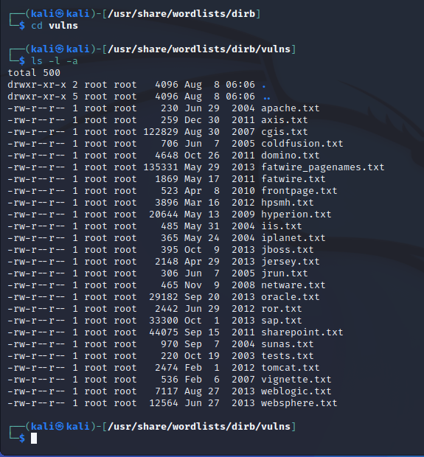

Step 7: Insert Command> dirb https://www.yahoo.com

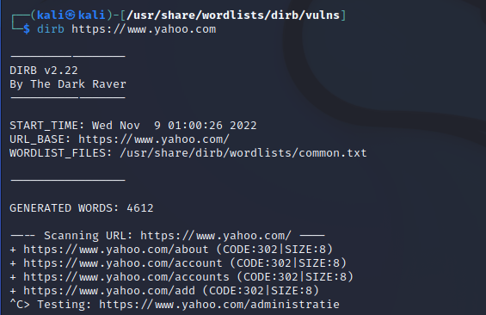

1. **Burp Suite**

Step 1: After downloading Burp Suite in guest machine. The first window comes is to login to Burp Suite Community Edition. Select your choice and click “Next” button.

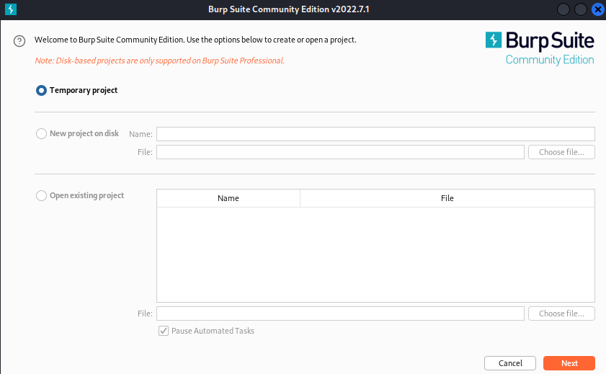

Step 2: Choose the required configuration and click on “Start Burp” button.

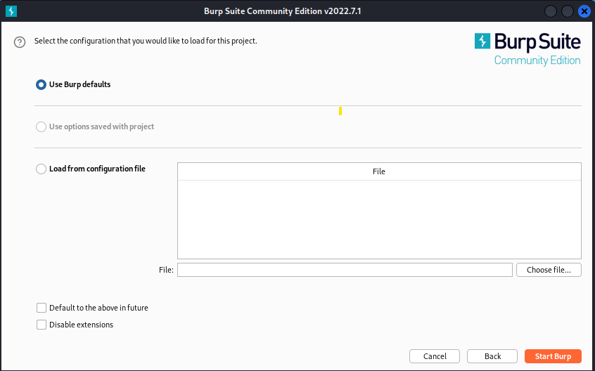

Step 3: The dashboard of Burp Suite will open to perform operation.

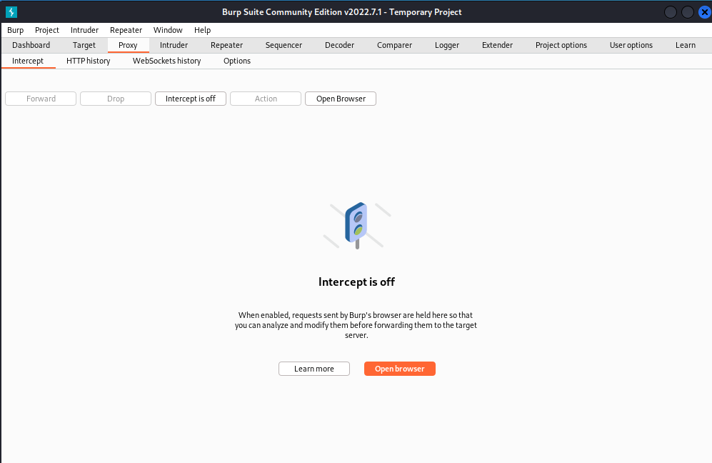

Step 4: Turn on Intercept by simply open browser .

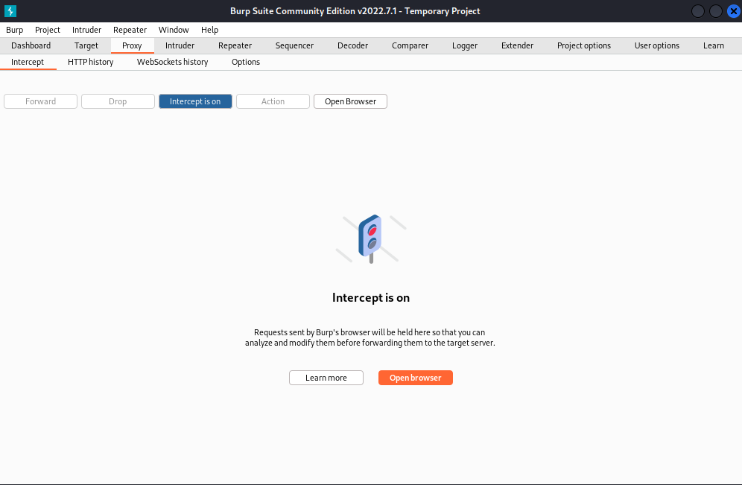

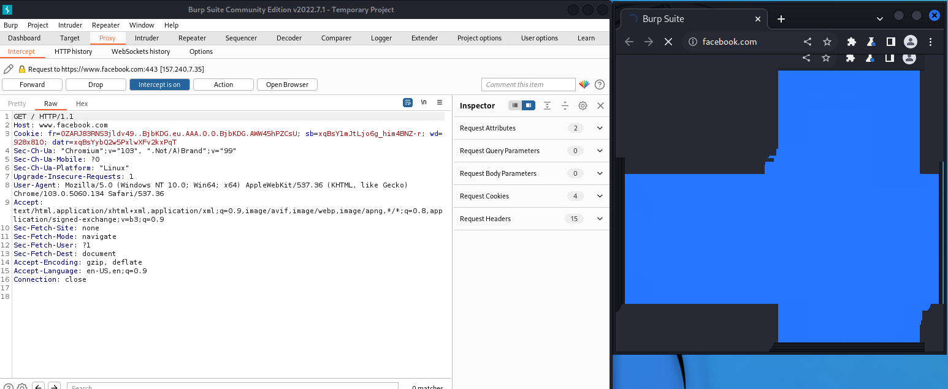

Step 5: Turn off the intercept after clicking on the forward twice/thrice:

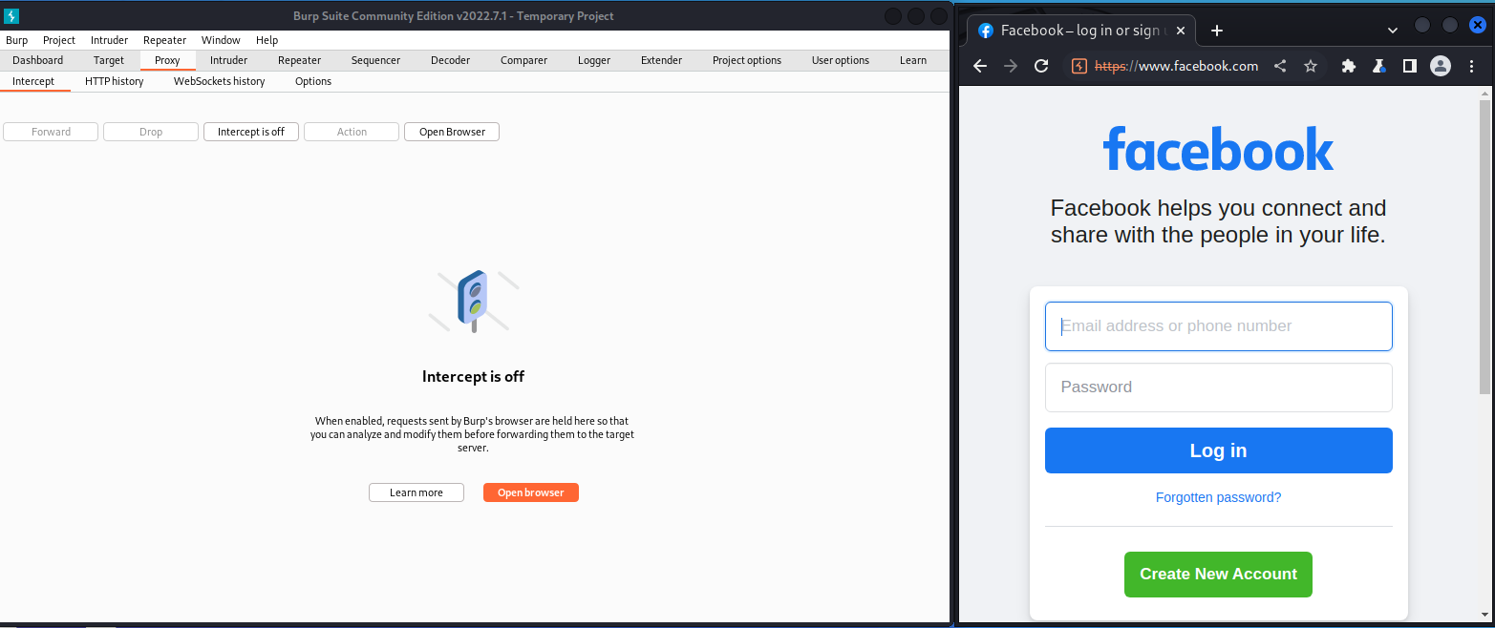

Step 6: See the HTTPhistory of host and by which Method.

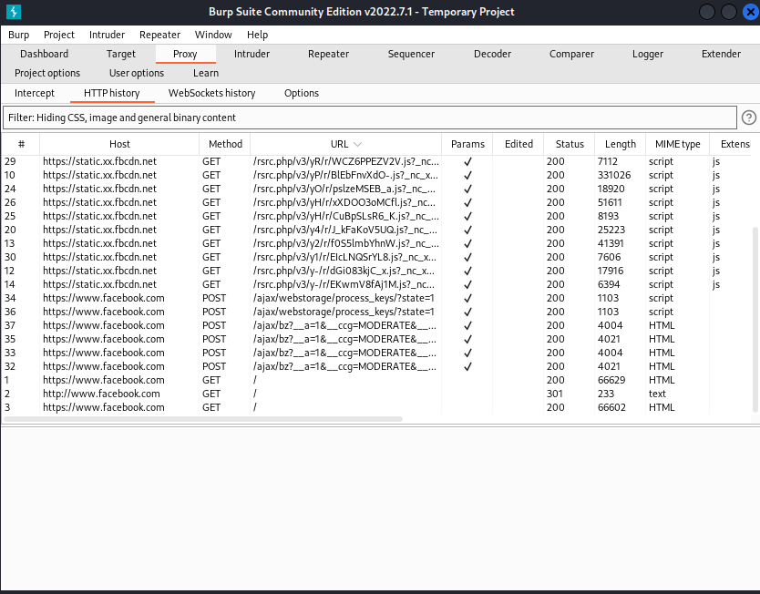

Step 7: Intruder feature allows user to automate attacks that send the same request many times, substituting specific values with predetermined payloads each time.

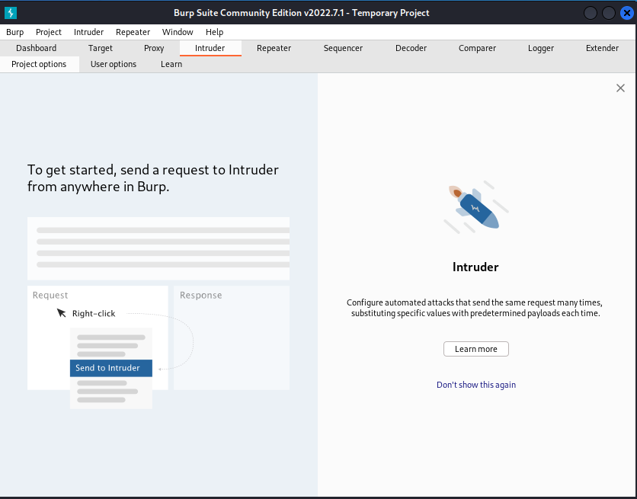

Step 8: We just turn all same request from a http server request to attackers by just right clicking on attackers side url and click on “Send to Intruder” or Ctrl+I.

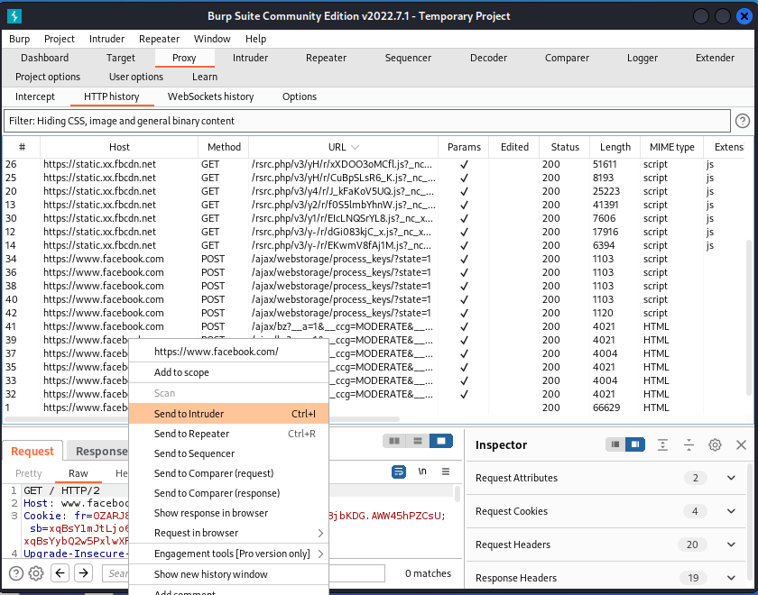

Step 9: We can select the “Attack Type:” and “Payload Positions “from specific URLs.

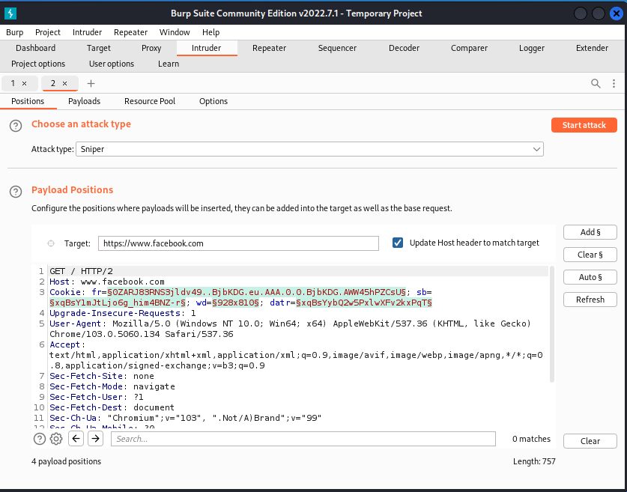

Step 10: Repeater allows to modify and resend individual requests to test how the server’s response changes based on your input.

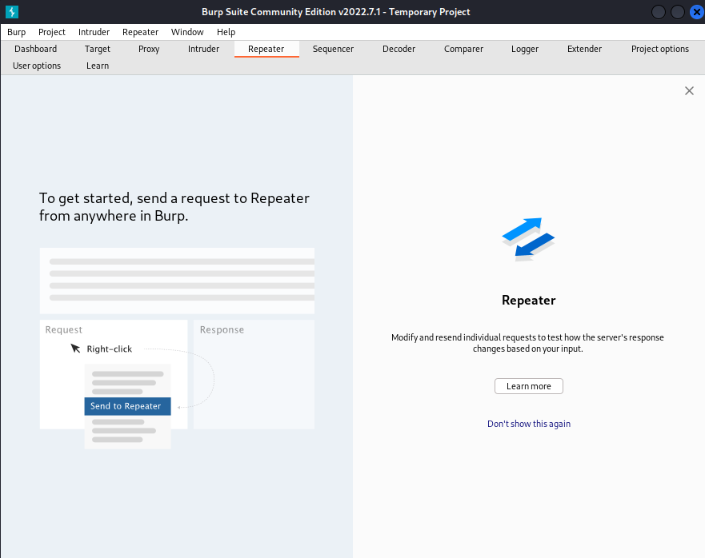

Step 11: We can send from HTTPserver Urls by right clicking on it and click on “Send to Intruder” or Ctrl+I.

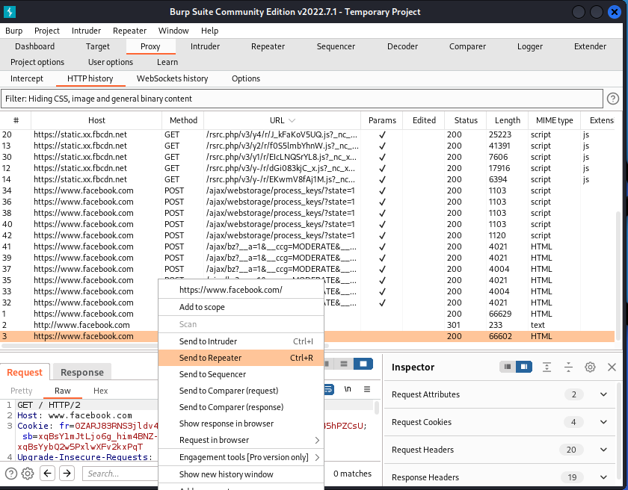

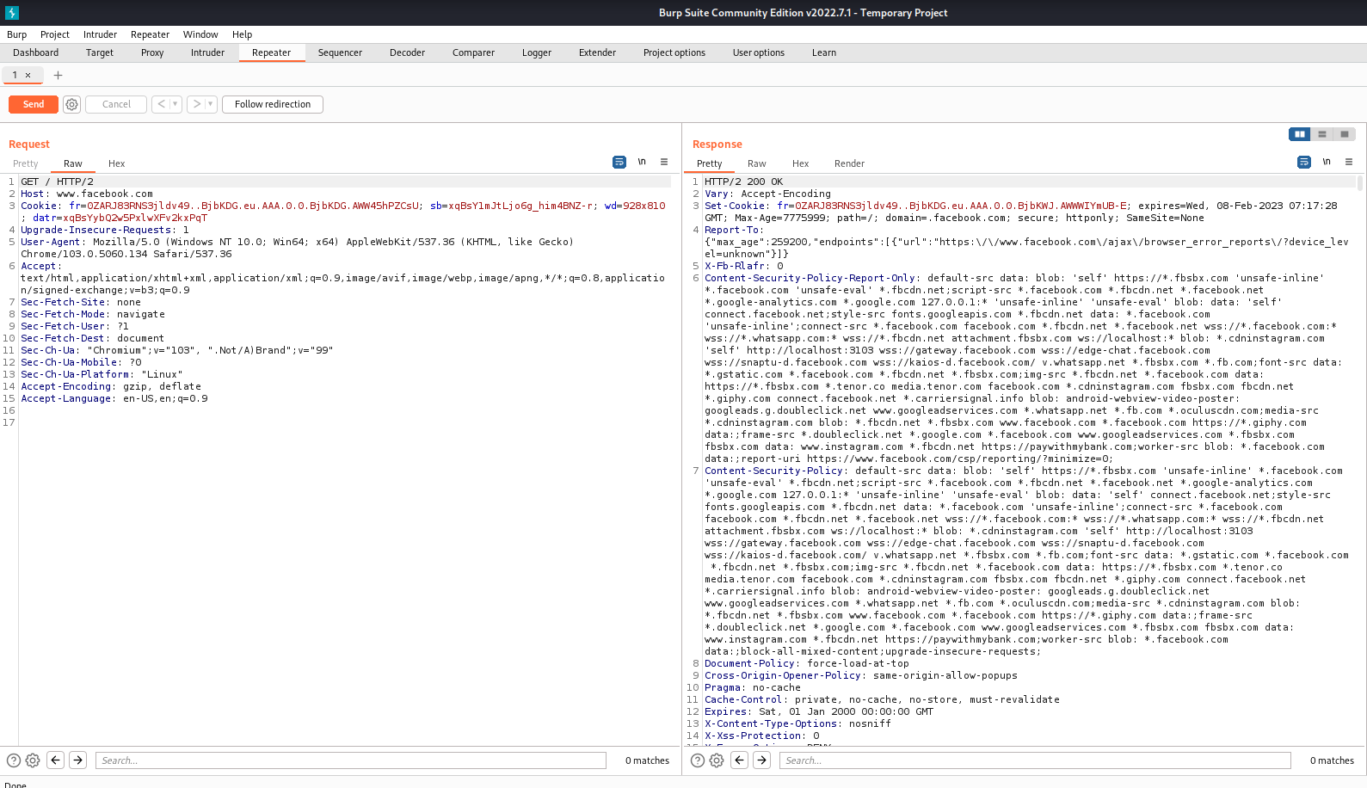

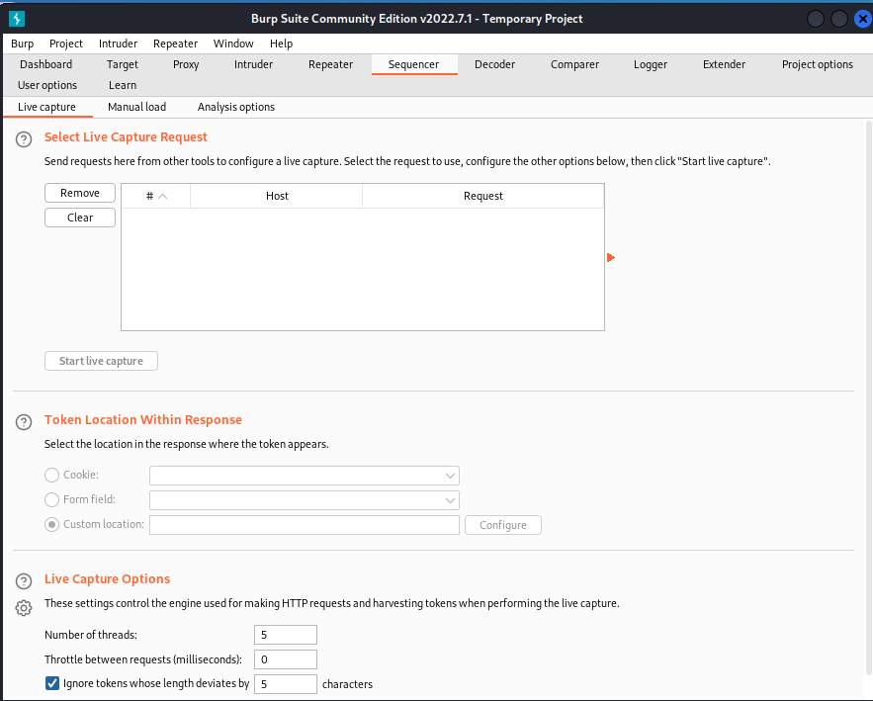

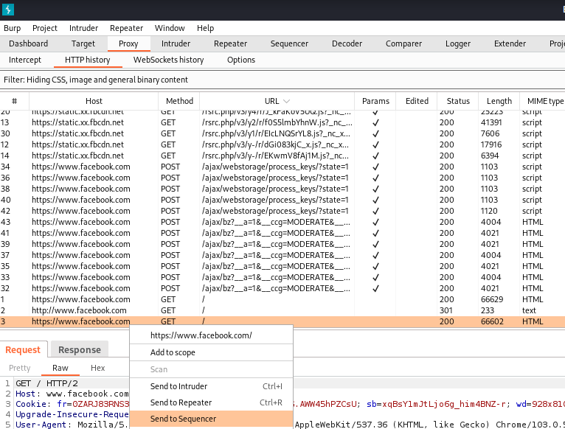

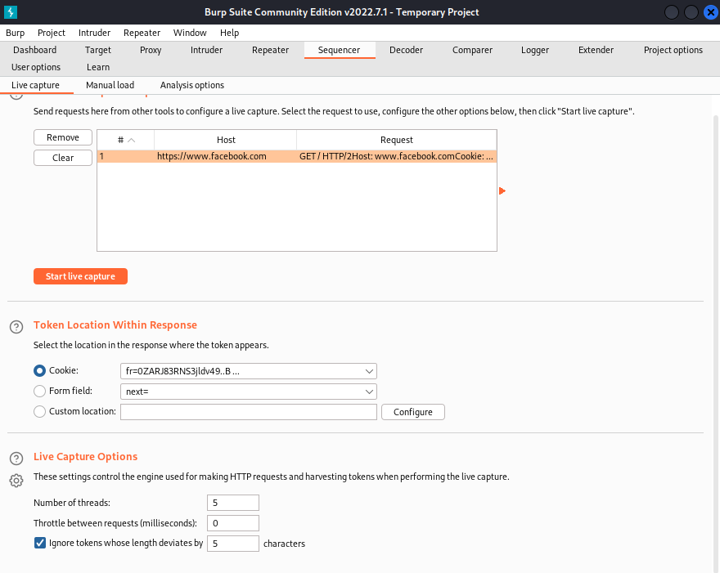

1. **Nikto**

Step 1: Insert Command> nikto

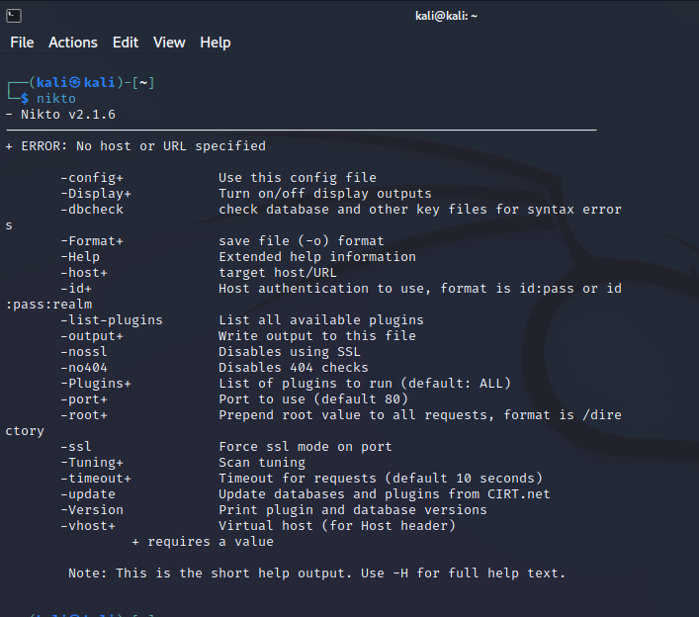

Step 2: Insert Command> ping [www.ajio.com](http://www.ajio.com) 🡪 nikto -h 116.50.83.240

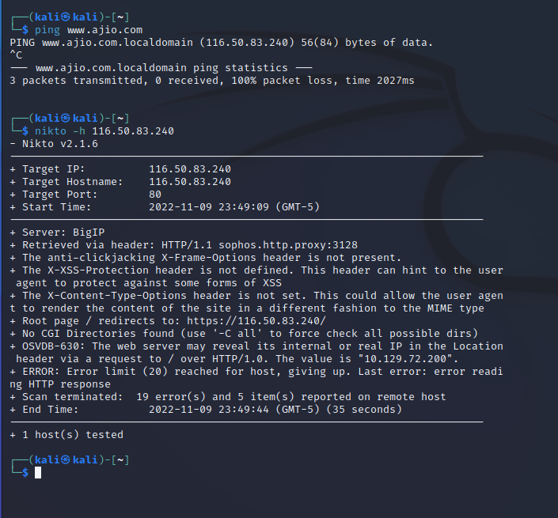

**PRACTICAL 9**

**(Client-Side Attacks)**

1. **HTA Attack**

Step 1: Open Kali Linux**>**Click on Applications>Social engineering tools

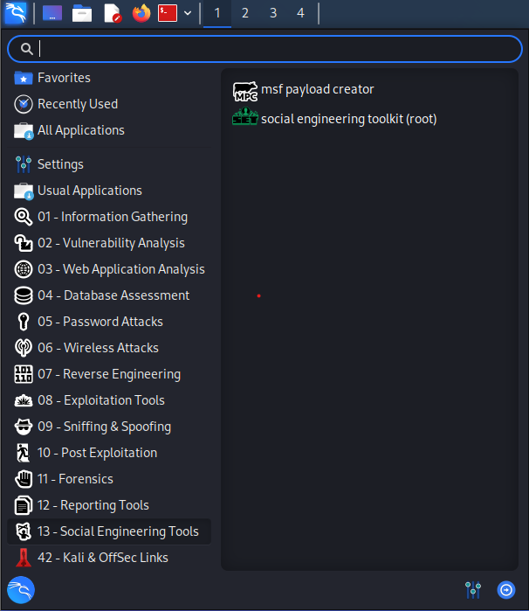

Step 2: Insert Command> Type "y”

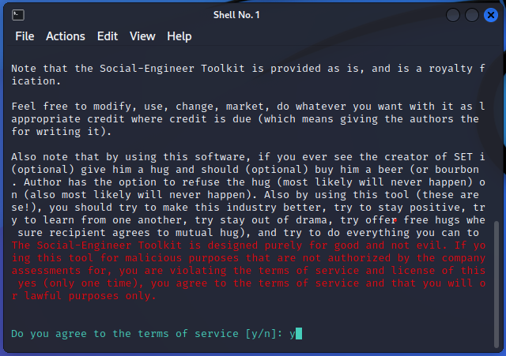

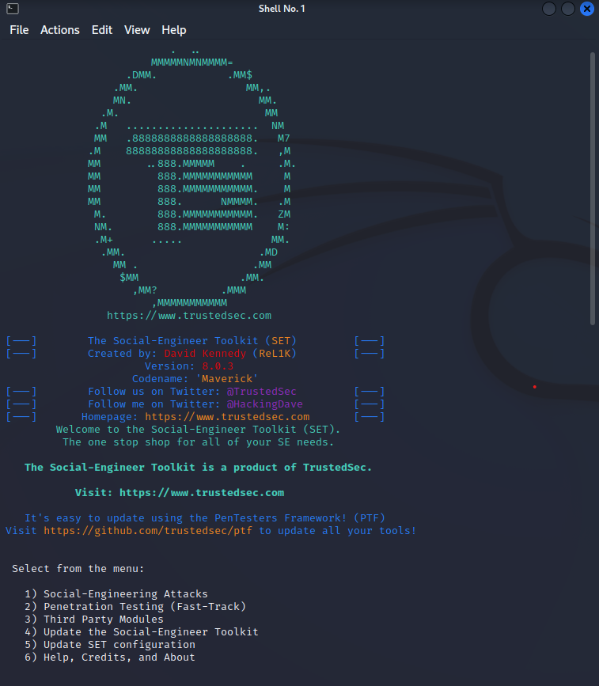

Step 3: Select webattack with respect to number.

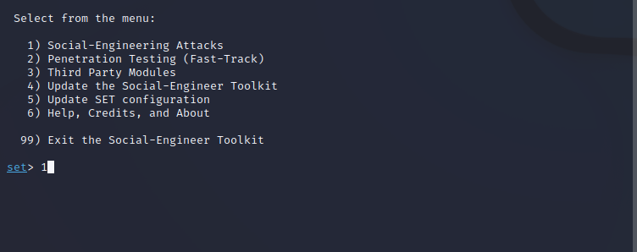

Step 4: Select “Website Attack Vectors”

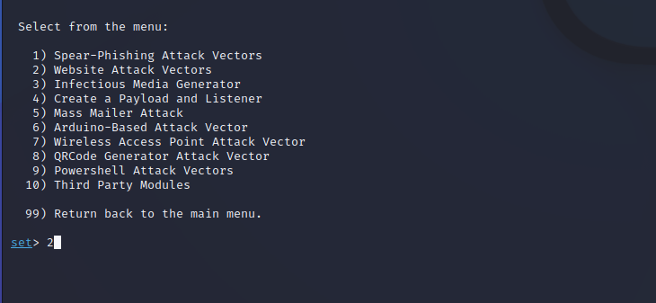

Step 5: Select “HTA Attack Method”

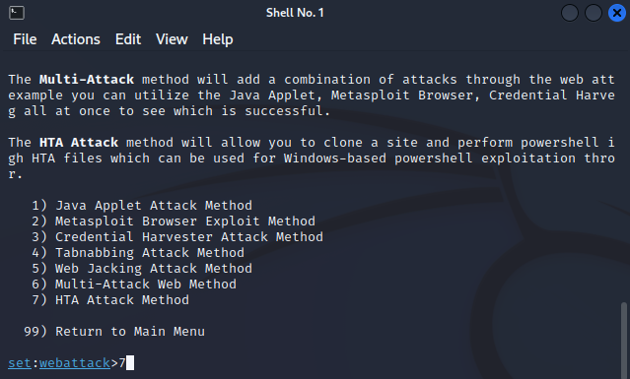

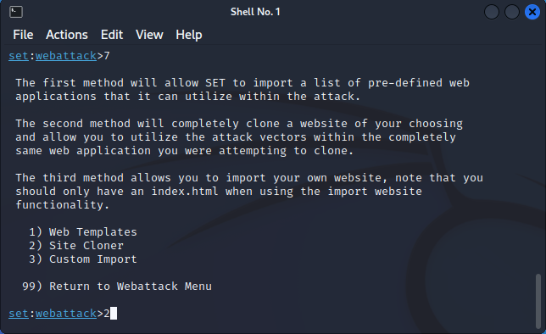

Step 6: Copy paste the website link in front of “url to clone”.

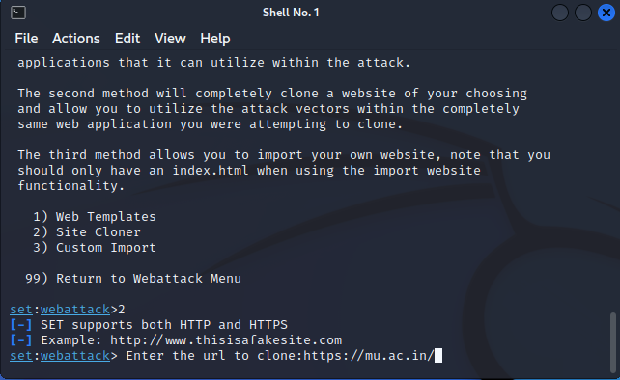

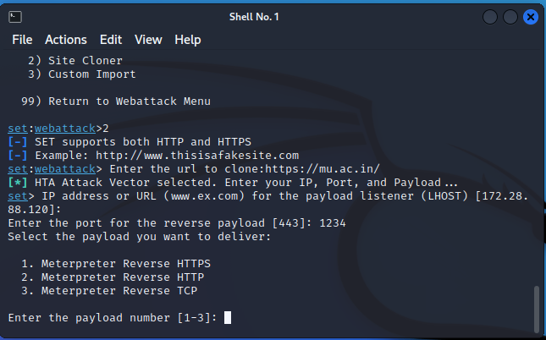

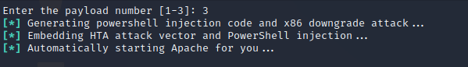

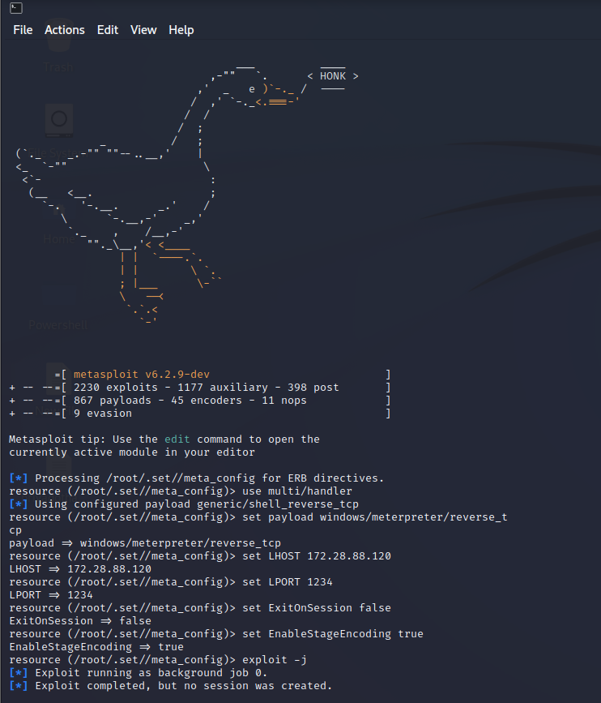



1. **Exploiting Microsoft Office**

Step 1: Install LibreOffice and John Ripper tool from the terminal.

Step 2: Insert Command> sudo apt install john

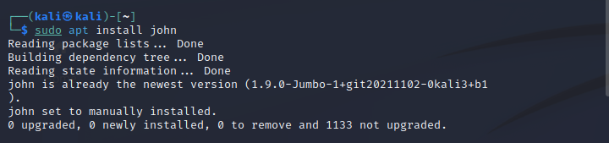

Step 3: Insert Command>sudo apt install libreoffice

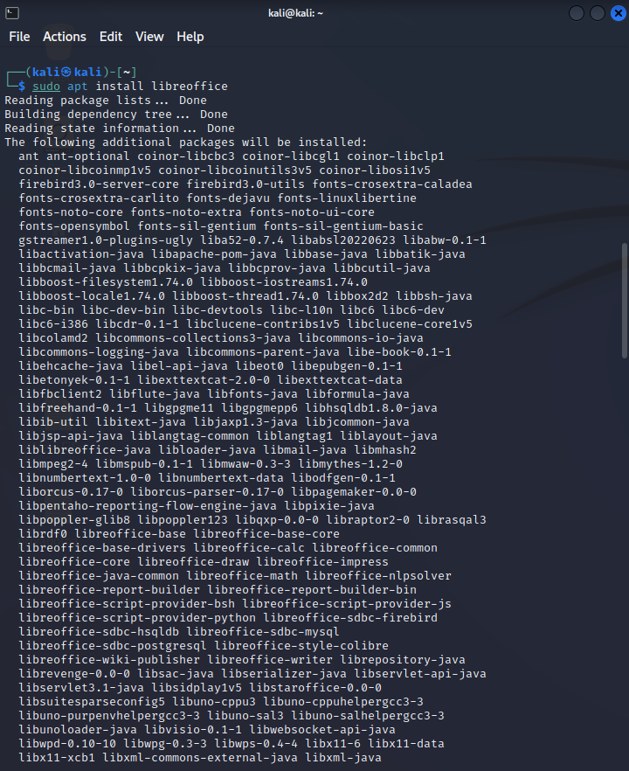

Step 4: Explore John Ripper tool using man john command: man john

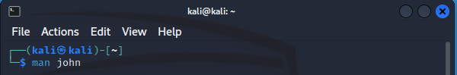

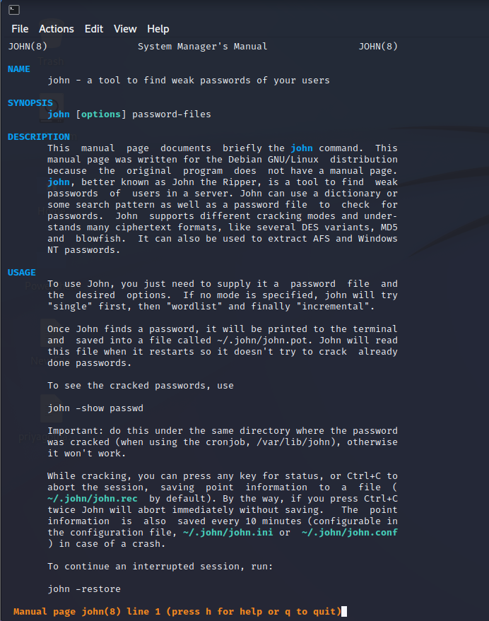

Now, Create & save a docx file in an password encrypted format. In the terminal, give the path of office2john.py file from john folder & also paste path of the path of the docx folder which you have created and give the access by creating any text file using the below command (eg. crack.txt).

Step 5: Insert Command> /usr/share/john/office2john.py /home/kali/Desktop/Target1.docx > crack.txt

Step 6: Insert Command> cat crack.txt

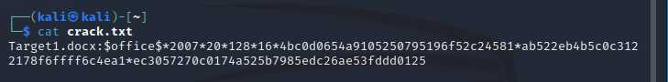Using the help command, we will get a command for cracking the password of the docx file.

Step 7: Insert Command> john -- h

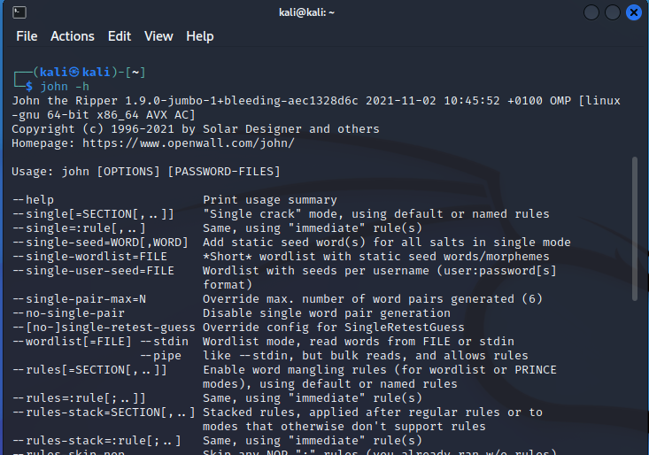

Crack the password using the length command. Here, we got the password which we cracked.

Step 8: Insert Command> john crack.txt – length=4

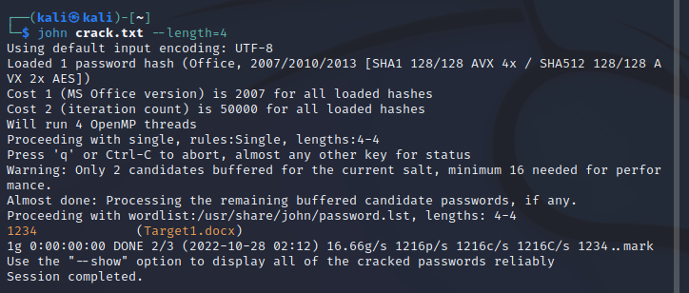

**PRACTICAL 10**

**(Password Attacks)**

1. **Wordlists, Brute Force Wordlists**

Step 1: Go to www.https://github.com/Mebus/cupp, Copy the URL from code section

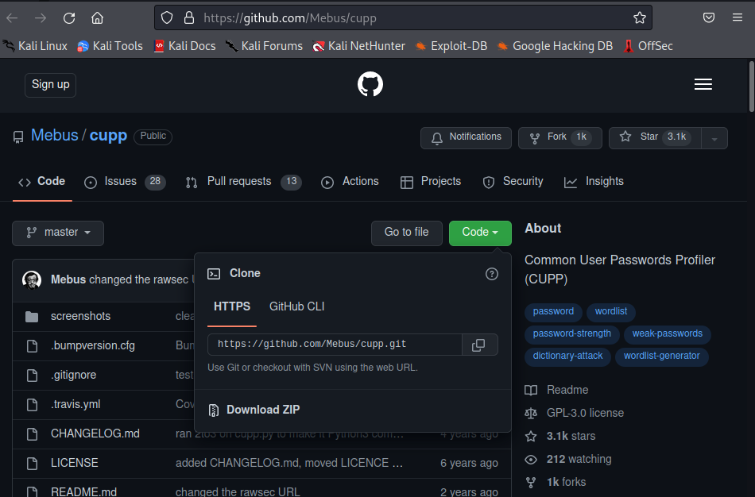

Step 2: Insert Command> cd Desktop

Step 3: Insert Command> git clone https://github.com/Mebus/cupp.git

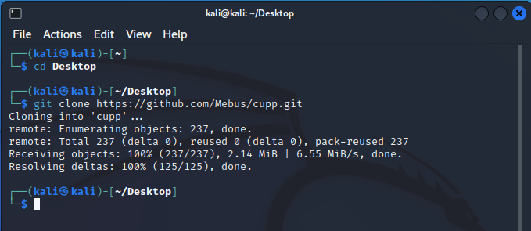

Step 4: Insert Command> cd cupp

Step 5: Insert Command> ls

Step 6: Insert Command> open the file cupp.py by writing the code “ ./cupp.py ”

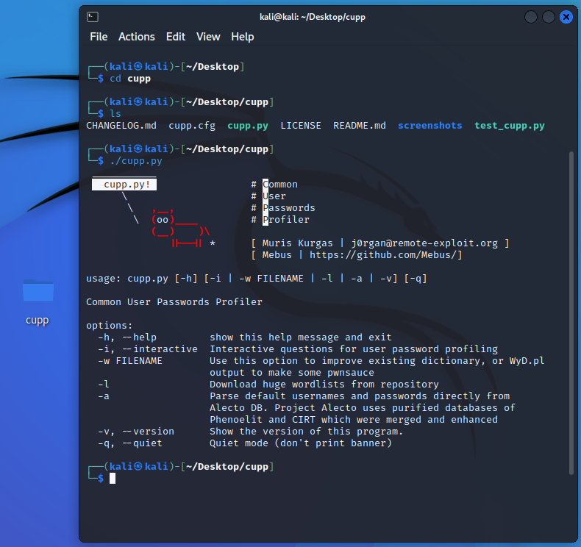

Step 7: Insert Command>./cupp.py -i

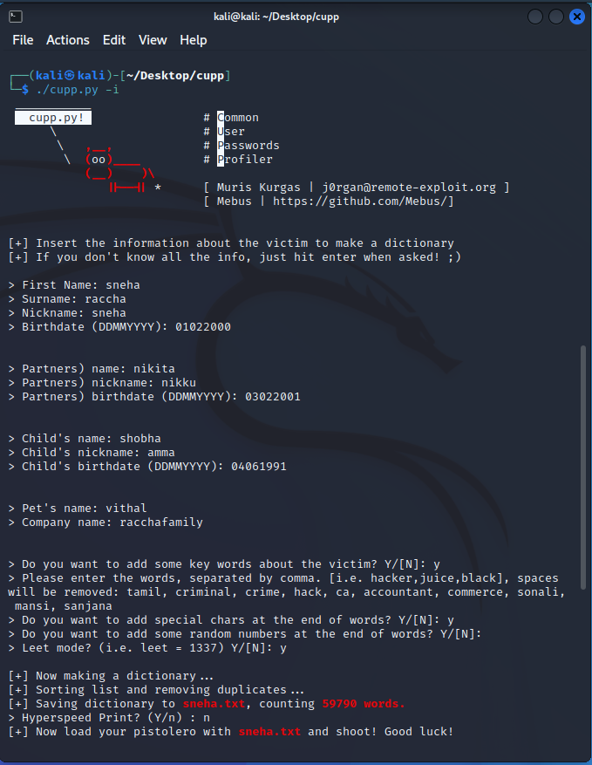

Step 8: After completing all details, “sneha.txt” is created with all possible configuration and sequence of words all containing details around 59790 words

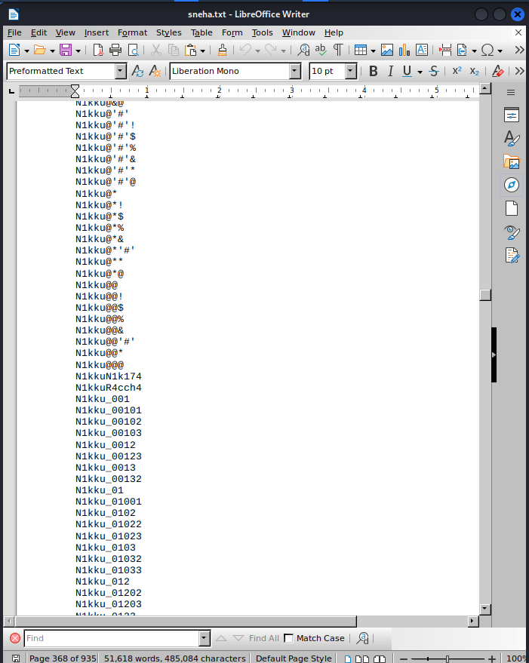

Step 9: Insert Command> leafpad

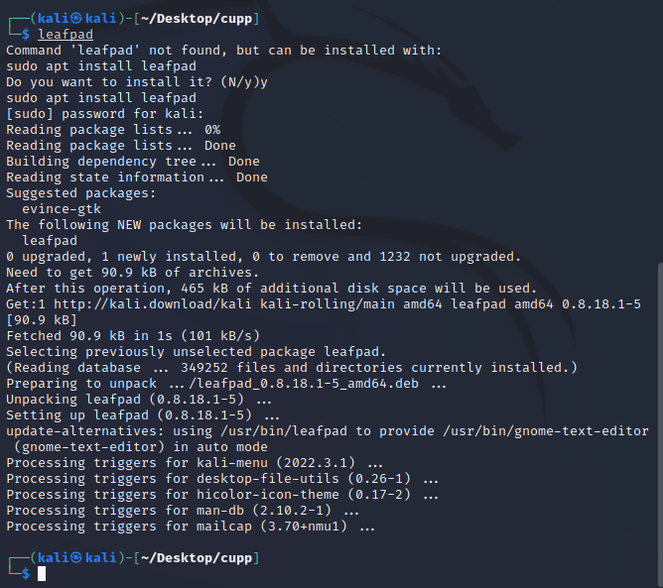

Step 10: Create a pass.txt file in Desktop with some data in it.

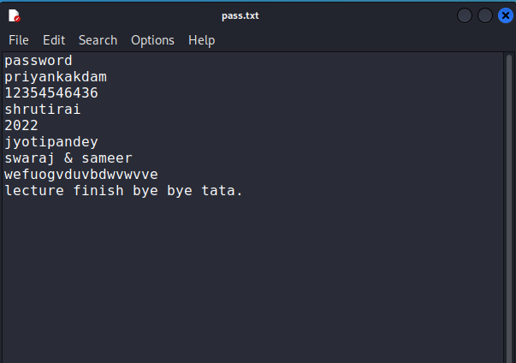

Step 11: Insert Command>./cupp.py –w /home/kali/Desktop/pass.txt

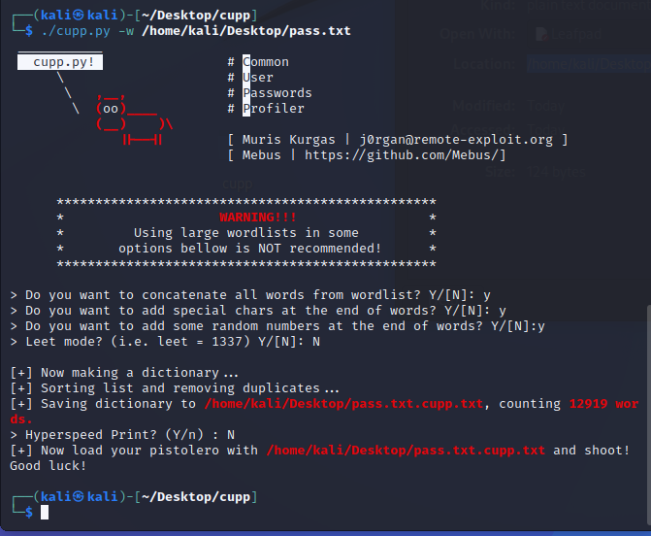

Step 12: Insert Command> It creates txt file in /home/kali/Desktop/pass.txt.cupp.txt with counting 12919 words in it.

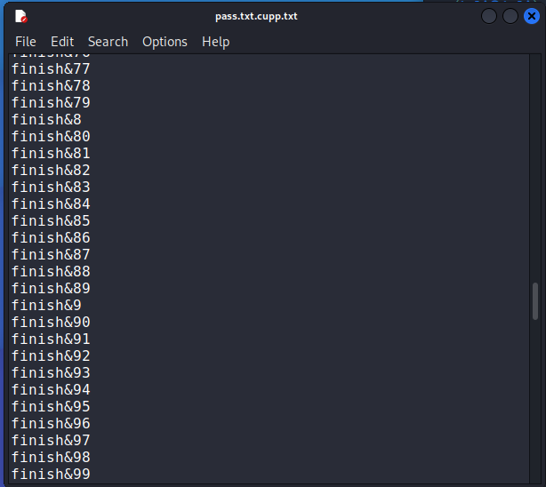

Step 13: Insert Command>./cupp.py -l

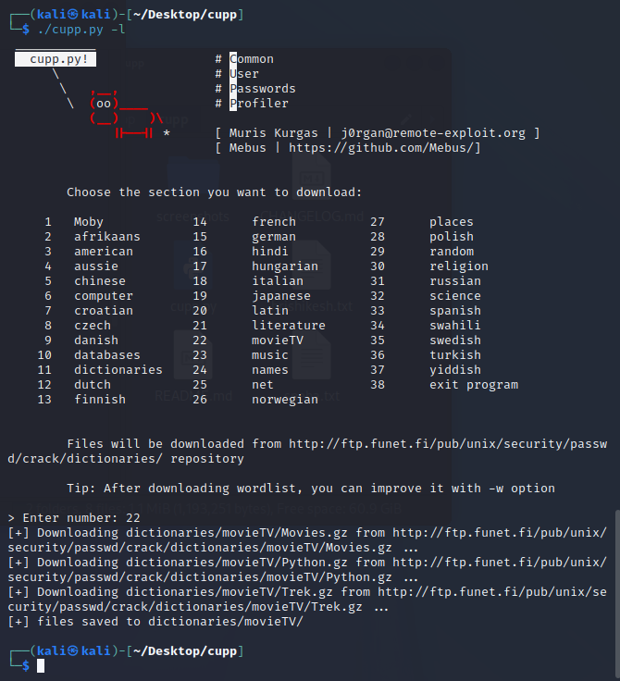

Step 14: When we enter number “22” , dictionaries were downloading from <http://ftp.funet.fi/pub/unix/security/passwd/crack/dictionaries/movieTV/Movies.gz> . We get data of “Movies.gz”, “Python.gz”, “Trek.gz”.

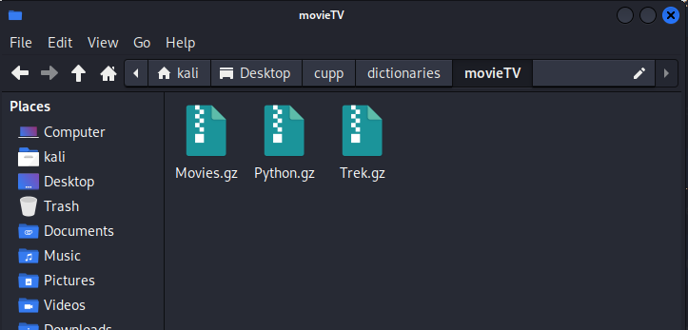

Step 15: Insert Command> Open “Movies.gz” file.

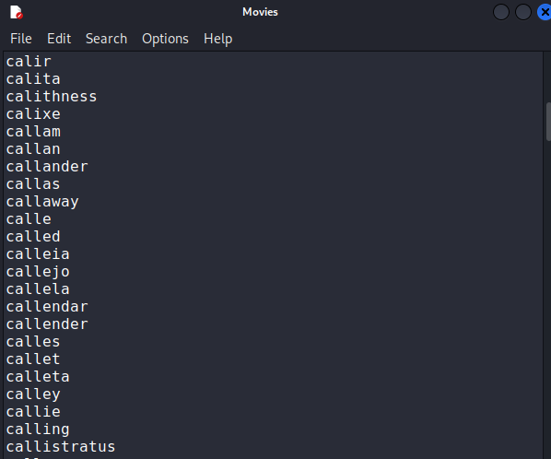

Step 16: Insert Command> Type command on terminal ./cupp.py -v

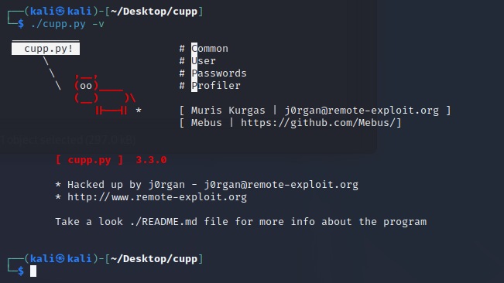

**Brute Force Wordlists**

Step 1: Insert Command> sudo su

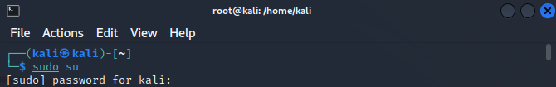

Step 2: Insert Command> crunch --h

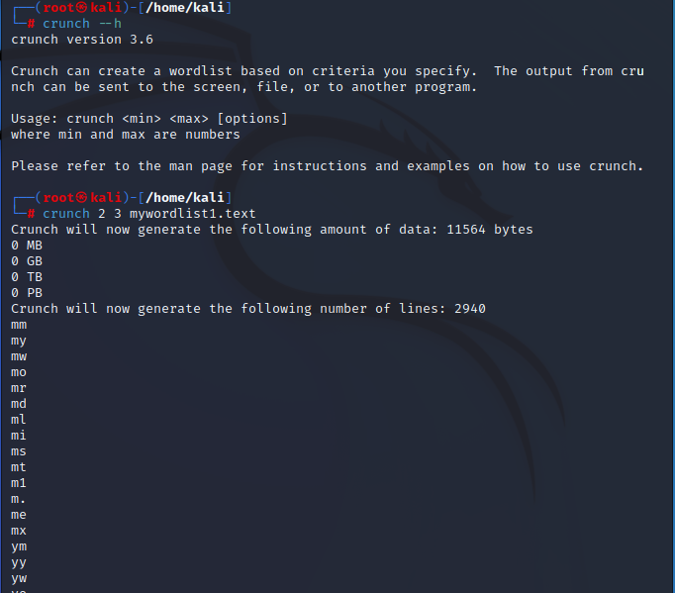

Step 3: Insert Command> crunch 5 6 angel

